


Organise food service operations
D1.HCC.CL2.05
Trainee Manual




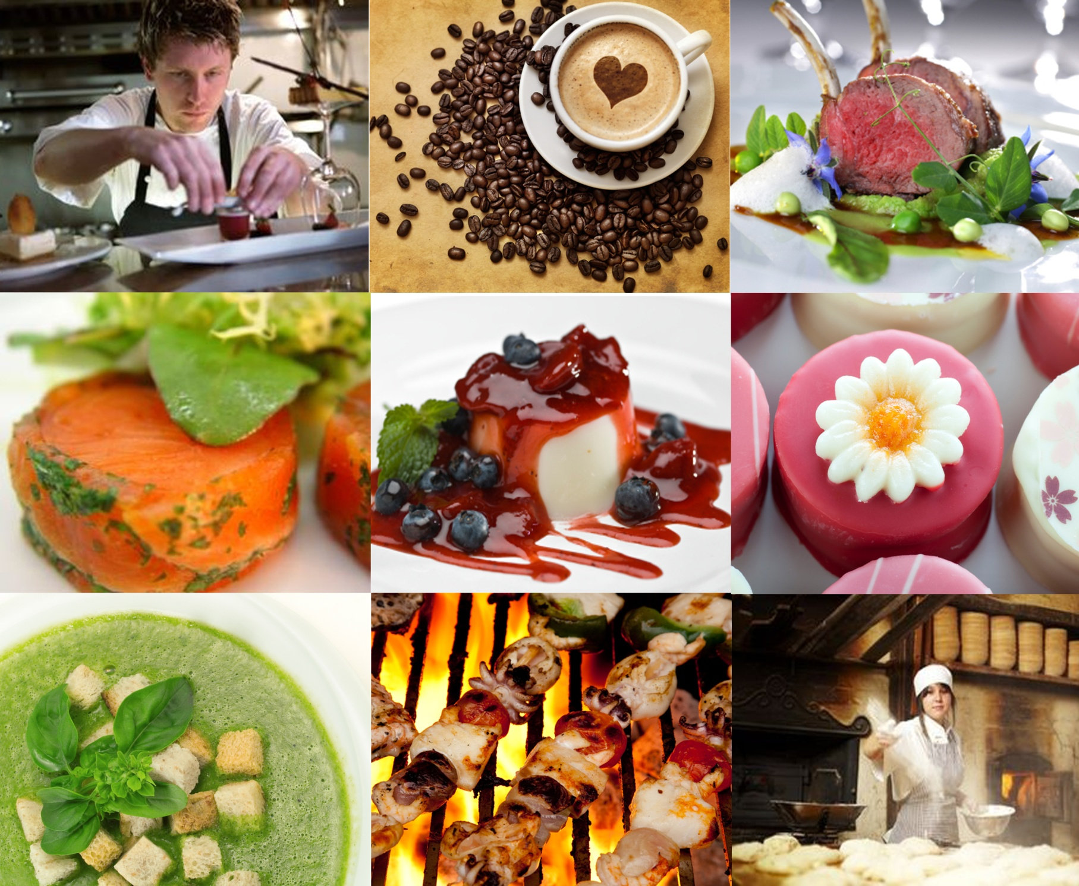

Organise food service operations

D1.HCC.CL2.05

Trainee Manual




Project Base
William Angliss Institute of TAFE
555 La Trobe Street
Melbourne 3000 Victoria
Telephone: |  | (03) 9606 2111
Facsimile: |  | (03) 9670 1330
Acknowledgements
Project Director: |  | Wayne Crosbie
Chief Writer: |  | Alan Hickman
Subject Writer: |  | Alan Hickman
Project Manager: |  | Alan Maguire
Editor: |  | Jim Irwin
DTP/Production: |  | Daniel Chee, Mai Vu, Riny Yasin, Kaly Quach

The Association of Southeast Asian Nations (ASEAN) was established on 8 August 1967. The Member States of the Association are Brunei Darussalam, Cambodia, Indonesia, Lao PDR, Malaysia, Myanmar, Philippines, Singapore, Thailand and Viet Nam.
The ASEAN Secretariat is based in Jakarta, Indonesia.
General Information on ASEAN appears online at the ASEAN Website: www.asean.org.
All text is produced by William Angliss Institute of TAFE for the ASEAN Project on “Toolbox Development for Front Office, Food and Beverage Services and Food Production Divisions”.
This publication is supported by the Australian Government’s aid program through the ASEAN-Australia Development Cooperation Program Phase II (AADCP II).
Copyright: Association of Southeast Asian Nations (ASEAN) 2013.
All rights reserved.
Disclaimer
Every effort has been made to ensure that this publication is free from errors or omissions. However, you should conduct your own enquiries and seek professional advice before relying on any fact, statement or matter contained in this book. The ASEAN Secretariat and William Angliss Institute of TAFE are not responsible for any injury, loss or damage as a result of material included or omitted from this course. Information in this module is current at the time of publication. Time of publication is indicated in the date stamp at the bottom of each page.
Some images appearing in this resource have been purchased from stock photography suppliers Shutterstock and iStockphoto and other third party copyright owners and as such are non-transferable and non-exclusive. Clip arts, font images and illustrations used are from the Microsoft Office Clip Art and Media Library. Some images have been provided by and are the property of William Angliss Institute.
Additional images have been sourced from Flickr and SKC and are used under Creative Commons licence: http://creativecommons.org/licenses/by/2.0/deed.en
File name: TM_Organise_food_service_operations_FN_030114





Table of contents
Introduction to trainee manual 1
Unit descriptor 3
Assessment matrix 5
Glossary 7
Element 1: Plan for food service production 9
Element 2: Prepare and produce food items for food service 31
Element 3: Set up kitchen for food service 39
Element 4: Hold and store products for food service 59
Element 5: Store products after food service to maintain quality 97
Presentation of written work 111
Recommended reading 113
Trainee evaluation sheet 115
Trainee Self-Assessment Checklist 117

Introduction to trainee manual

To the Trainee
Congratulations on joining this course. This Trainee Manual is one part of a ‘toolbox’ which is a resource provided to trainees, trainers and assessors to help you become competent in various areas of your work.
The ‘toolbox’ consists of three elements:
- A Trainee Manual for you to read and study at home or in class
- A Trainer Guide with Power Point slides to help your Trainer explain the content of the training material and provide class activities to help with practice
- An Assessment Manual which provides your Assessor with oral and written questions and other assessment tasks to establish whether or not you have achieved competency.
The first thing you may notice is that this training program and the information you find in the Trainee Manual seems different to the textbooks you have used previously. This is because the method of instruction and examination is different. The method used is called Competency based training (CBT) and Competency based assessment (CBA). CBT and CBA is the training and assessment system chosen by ASEAN (Association of South-East Asian Nations) to train people to work in the tourism and hospitality industry throughout all the ASEAN member states.
What is the CBT and CBA system and why has it been adopted by ASEAN?
CBT is a way of training that concentrates on what a worker can do or is required to do at work. The aim is of the training is to enable trainees to perform tasks and duties at a standard expected by employers. CBT seeks to develop the skills, knowledge and attitudes (or recognise the ones the trainee already possesses) to achieve the required competency standard. ASEAN has adopted the CBT/CBA training system as it is able to produce the type of worker that industry is looking for and this therefore increases trainees’ chances of obtaining employment.
CBA involves collecting evidence and making a judgement of the extent to which a worker can perform his/her duties at the required competency standard. Where a trainee can already demonstrate a degree of competency, either due to prior training or work experience, a process of ‘Recognition of Prior Learning’ (RPL) is available to trainees to recognise this. Please speak to your trainer about RPL if you think this applies to you.
What is a competency standard?
Competency standards are descriptions of the skills and knowledge required to perform a task or activity at the level of a required standard.
242 competency standards for the tourism and hospitality industries throughout the ASEAN region have been developed to cover all the knowledge, skills and attitudes required to work in the following occupational areas:
- Housekeeping
- Food Production
- Food and Beverage Service
- Front Office
- Travel Agencies
- Tour Operations.
All of these competency standards are available for you to look at. In fact you will find a summary of each one at the beginning of each Trainee Manual under the heading ‘Unit Descriptor’. The unit descriptor describes the content of the unit you will be studying in the Trainee Manual and provides a table of contents which are divided up into ‘Elements’ and ‘Performance Criteria”. An element is a description of one aspect of what has to be achieved in the workplace. The ‘Performance Criteria’ below each element details the level of performance that needs to be demonstrated to be declared competent.
There are other components of the competency standard:
- Unit Title: statement about what is to be done in the workplace
- Unit Number: unique number identifying the particular competency
- Nominal hours: number of classroom or practical hours usually needed to complete the competency. We call them ‘nominal’ hours because they can vary e.g. sometimes it will take an individual less time to complete a unit of competency because he/she has prior knowledge or work experience in that area.
The final heading you will see before you start reading the Trainee Manual is the ‘Assessment Matrix’. Competency based assessment requires trainees to be assessed in at least 2 – 3 different ways, one of which must be practical. This section outlines three ways assessment can be carried out and includes work projects, written questions and oral questions. The matrix is designed to show you which performance criteria will be assessed and how they will be assessed. Your trainer and/or assessor may also use other assessment methods including ‘Observation Checklist’ and ‘Third Party Statement’. An observation checklist is a way of recording how you perform at work and a third party statement is a statement by a supervisor or employer about the degree of competence they believe you have achieved. This can be based on observing your workplace performance, inspecting your work or gaining feedback from fellow workers.
Your trainer and/or assessor may use other methods to assess you such as:
- Journals
- Oral presentations
- Role plays
- Log books
- Group projects
- Practical demonstrations.
Remember your trainer is there to help you succeed and become competent. Please feel free to ask him or her for more explanation of what you have just read and of what is expected from you and best wishes for your future studies and future career in tourism and hospitality.

Unit descriptor
Organise food service operations
This unit deals with the skills and knowledge required to Organise food service operations in a range of settings within the hotel and travel industries workplace context.
Unit Code:
D1.HCC.CL2.05
Nominal Hours:
50 hours

Element 1: Plan for food service production
Performance Criteria
1.1 Plan menu for specific event/occasion including resources
1.2 Determine quantities required for food items as per standard recipes
1.3 Order products required from suppliers with specifications for products
1.4 Prepare production sheets/work schedules

Element 2: Prepare and produce food items for food service
Performance Criteria
2.1 Identify and plan work flow
2.2 Communicate with production team

Element 3: Set up kitchen for food service
Performance Criteria
3.1 Place personnel ready for service
3.2 Allocate equipment
3.3 Determine service style to suit operation
3.4 Determine service flow for service style

Element 4: Hold and store products for food service
Performance Criteria
4.1 Use appropriate preparation and cooking methods
4.2 Use appropriate equipment
4.3 Follow food safety requirements
4.4 Hold menu items
4.5 Reheat menu items
4.6 Serve and present food items in line with customer volume

Element 5: Store products after food service to maintain quality
Performance Criteria
5.1 Store fresh and/or Cryovac items correctly
5.2 Change storage containers and trays to enterprise standards
5.3 Label Items correctly
5.4 Store products in correct conditions to maintain freshness and quality and minimise wastage

Assessment matrix
Showing mapping of Performance Criteria against Work Projects, Written Questions and Oral Questions
The Assessment Matrix indicates three of the most common assessment activities your Assessor may use to assess your understanding of the content of this manual and your performance – Work Projects, Written Questions and Oral Questions. It also indicates where you can find the subject content related to these assessment activities in the Trainee Manual (i.e. under which element or performance criteria). As explained in the Introduction, however, the assessors are free to choose which assessment activities are most suitable to best capture evidence of competency as they deem appropriate for individual students.
 |  |  | Work Projects | Written Questions | Oral Questions
Element 1: Plan for food service production
1.1 | Plan menu for specific event/occasion including resources |  | 1.1 | 1, 2, 3 | 1
1.2 | Determine quantities required for food items as per standard recipes |  | 1.1 | 4, 5, 6 | 2
1.3 | Order products required from suppliers with specifications for products |  | 1.1 | 7, 8 | 3
1.4 | Prepare production sheets/work schedules |  | 1.1 | 9, 10 | 4
Element 2: Prepare and produce food items for food service
2.1 |  | Identify and plan work flow | 2.1 | 11, 12 | 5
2.2 |  | Communicate with production team | 2.1 | 13, 14, 15 | 6
Element 3: Set up kitchen for food service
3.1 | Place personnel ready for service |  | 3.1 | 16, 17, 18 | 7
3.2 | Allocate equipment |  | 3.1 | 19, 20, 21 | 8
3.3 | Determine service style to suit operation |  | 3.1 | 22 – 25 | 9
3.4 | Determine service flow for service style |  | 3.1 | 26, 27 | 10
Element 4: Hold and store products for food service
4.1 |  | Use appropriate preparation and cooking methods | 4.1 | 28 – 34 | 11
4.2 |  | Use appropriate equipment | 4.1 | 35, 36 | 12
4.3 |  | Follow food safety requirements | 4.2 | 37, 38, 39 | 13
4.4 |  | Hold menu items | 4.2 | 40, 41 | 14
4.5 |  | Reheat menu items | 4.2 | 42 | 15
4.6 |  | Serve and present food items in line with customer volume | 4.2 | 43, 44 | 16
Element 5: Store products after food service to maintain quality
5.1 | Store fresh and/or Cryovac items correctly |  | 5.1 | 45, 46, 47 | 17
5.2 | Change storage containers and trays to enterprise standards |  | 5.1 | 48, 49 | 18
5.3 | Label Items correctly |  | 5.1 | 50, 51 | 19
5.4 | Store products in correct conditions to maintain freshness and quality and minimise wastage |  | 5.1 | 52 | 20

Glossary
Term | Explanation
A la carte | French: from the card/menu
Bain Marie | A French term: a holding device used to keep hot foods hot for service and display
Barrier to communication | Anything that interferes with the communication process
Cross contamination | The result of transferring bacteria/contamination from one area/item to another
Cryovac | A commercial, trade-marked process where meat is sealed in plastic bags and the air is removed by a vacuum pump to inhibit bacterial growth and increase shelf life
FIFO | First In – First Out: standard method of stock rotation for food
FSP | Food Safety Plan or Program
Finger food | Small food items designed to be eaten by guests who are standing up using the fingers as opposed to using cutlery
Flambéing | Flaming of dishes using alcohol as part of gueridon service
Garnish | An edible decoration used to enhance the overall presentation of a menu item
Gueridon service | Tableside service and or cookery – a fine dining option
MICE | Meetings, Incentives, Conventions and Exhibitions
Menu item | A dish listed on the menu
Mise en place | (French) To put in place; to get things ready
Plating | Placing food onto plates in the kitchen ready for service
Potentially hazardous food | Food known to be commonly associated with food poisoning outbreaks; it is usually high protein, high moisture and low acid food. Also known as ‘High risk food’ or ‘Potentially dangerous food’
Re-thermalisation | Re-heating
Retailers | Businesses that sell to the public
SOP | Standard Operating Procedure
Service à la française | Family (French) service: food served in large dishes to guest table and guests serve themselves from these dishes
Service platforms | Items used as a base for food presentation
Silver service | The use of silver service gear (spoon and fork) to serve food from salvers/platters to guest plates at the table
Standard recipe | The recipe (ingredients and method) which has been approved by the venue as being the mandatory way to prepare a menu item
Table d’hôte | French: Table of the host. Set menu
Temperature Danger Zone | The temperature range in which bacteria multiply most rapidly: 5°C - 60°C
Thawing food | Defrosting food
The pass | A location in the kitchen where orders are placed by wait staff and plated meals are handed over to wait staff for service
Vermin | Pests, such as insects and rodents
Wholesalers | Businesses that sell to other businesses/the trade
Working dirt | The dirt generated as a result of undertaking your normal food-related duties for a shift. It does not refer to dirt from a previous shift or day

Element 1:
Plan for food service production

1.1 Plan menu for specific event/occasion including resources

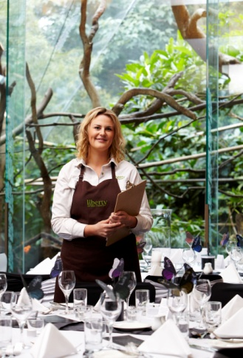
Introduction
A key requirement in organising food service operations is to plan the menu to be prepared and served.
This section explains why this stage in the planning process is so important, presents examples of a range of occasions which may need a menu to be prepared, names people who you may involve in menu planning, and identifies basic menu options/types.

The importance of planning the menu
A menu is a list of the dishes which will be offered for a particular service session.
It is the basis of planning and control mechanism for all food sessions.
Everything that happens in the kitchen and in terms of food production and food service flows from and is based on the dishes listed on the menu.
It is important to plan menus for every food service and/or event/occasion in order to:
- Meet customer expectations – and satisfy any identified needs of the customer (especially for functions and special events) which may relate to:
- Religious needs
- Dietary and health-related needs
- Cultural requirements
- Age-specific preferences – especially for children and the elderly
- Identified gender-related preferences
- Provide a basis for placing orders with suppliers – for the food/ingredients required
- Check the required ingredients are available – or are ‘in season’
- Verify the venue has sufficient and necessary equipment (physical resources) to produce the menu items – different dishes/cooking methods require different cooking equipment. There is a need to avoid cooking all dishes using the same cooking style and piece of equipment
- Confirm the dishes can be effectively and efficiently served to customers – after the food has been prepared/cooked
- Ensure staff (human resources) can produce the required menu items – which may relate to their experience, the need to practice dishes, the necessity to provide training and/or the need to employ sufficient numbers of workers
- Generate standard recipes for all identified dishes – see next section
- Make sure the food cost for the menu is acceptable – in accordance with venue requirements and where applicable – such as for functions or customer constraints
- Include local ingredients – to support the local area and promote local products
- Balance the menu – there is commonly a need to balance a menu in terms of achieving an appropriate blend of:
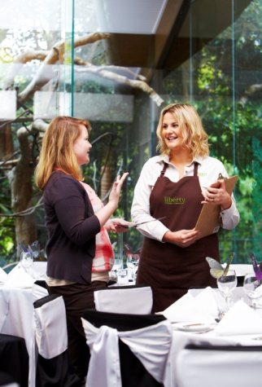
- Primary ingredients
- Cooking styles
- Textures
- Tastes
- Colours
- Nutrition
- Salads and vegetables
- Sauces
- Choices available between courses.

Examples of occasions requiring a menu to be prepared
You may be asked to plan menus to address the needs of a variety of different requirements such as:
- Normal day-to-day operation of food outlets in the venue.
- These operations may cover a range of traditional and/or modern dining/food options such as:
- Dining rooms – standard, themed, fine dining
- Bistro
- Café
- Take away
- Rooms service
- Breakfast, lunch, dinner
- Morning tea, afternoon tea and supper
- Specific occasions – these may include:
- Functions – for small or large groups such as birthdays, wedding receptions, private parties and cocktail parties
- Events – including catering required to support MICE
- Religious festivals and events
- Cultural festivals and events
- Ceremonial occasions.

People to involve
You will be required to liaise with the following people from time-to-time when planning menus:
- Management – to ensure you meet the requirements of the business in terms of:
- The direction they want the business to take and the image of the property
- Pricing and profit
- Clients – these are the people who are booking/paying for functions, events and special occasions in order to:
- Determine their needs
- Identify guest numbers
- Establish dates and service times
- The Marketing department of the venue – with reference to:
- Identifying advertising and promotion that has been done or is to be undertaken regarding food available
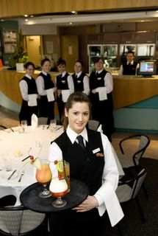
- Feedback obtained from customers regarding satisfaction with dishes, complaints and compliments as well as requests and suggestions for menu items
- Other kitchen staff – who should be involved to:
- Allow you to benefit from their experience
- Inform you of relevant issues regarding suggestions and options for dishes
- Assist with supporting activities – such as ordering food/supplies, creating standard recipes, basic food preparation
- Food service supervisor – this person is in-charge of waiting staff and they may be involved to ensure waiting staff are able to properly serve the food which Is going to be prepared
- Nominated specialist consultants – these may include:
- Dieticians
- Health and medical practitioners
- Religious personnel.

Basic menu options
There are several industry-wide menu options (types of menus) you may be asked to prepare.
A la carte menus
A la carte is the term used for a menu that has individually priced dishes.
Dishes on an à la carte menu are divided into ‘courses’ such as entrées, salads, mains and desserts.
A la carte is a French term and means ‘from the card/menu’.
Table d’hôte menus
A table d’hôte menu is a menu that has a set price for a number of courses.
‘Table d’hôte’ is a French term and means ‘table of the host’.
It is often referred to as a ‘set menu’.
Most menus for functions and events are table d’hôte/set menus.
All courses are included in the one set price and must be paid for by the guests even if they do not eat every course.
A typical set menu may have two to four choices of an entrée, two to four choices of a main and two choices of a dessert.
Cyclical menus
A cyclical menu is one where the menu repeats on a cyclical basis, say every week or two weeks.
They are frequently used in hospitals.
They are set menus where (for example) the menu is different for every day of the week but at the end of the cycle, the same menu is repeated.
Special needs menus
Some venues develop menus for certain dietary, religious or cultural needs.
Special cultural groups may include any ethnic, cultural or religious groups with special dietary requirements or sanctions, such as:
- Kosher
- Halal
- Vegetarian
- Hindu.
Other special dietary requirements can relate to health issues, allergies and/or lifestyle preferences and may include:
- Vegetarian
- Vegan
- Modified sodium or potassium
- Low-fat or low-cholesterol
- Lacto-ovo
- High-fibre
- Gluten-free
- High or low-energy
- Diabetic
- Modified texture
- High or low-protein
- Food exclusions for allergies and food intolerance
- Food exclusions related to specific medications
- Contemporary eating regimes and trends, such as:
- Macrobiotic
- Liver cleansing and elimination
- High or low carbohydrate.
Children’s menus
The ‘Children’s menu’ is designed specifically for children.
It features:
- Dishes known to be popular with children
- Language appropriate to children
- Smaller serve sizes.
Buffet menus
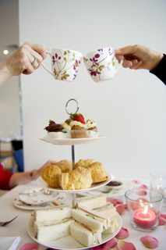
This is very popular food service option and often used at functions.
Items are prepared in advance and displayed on ’common’ tables for perusal and selection by customers.
Menu usually offers all items at the one set price with children often receiving a reduced rate.
Guests are generally allowed to eat as much as they want.
Menu items can include soups, hot and cold entrees, cold and hot meats, salads, vegetables, seafood, desserts, with tea and coffee.
Buffets are usually self-service with waiting staff replenishing food, and clearing plates, from the buffet and guest tables.

More information
Visit the following sites for more information:
- http://www.slideshare.net/bhavinsp/menu-planning-costing-engineering
- http://www.slideshare.net/jigisjig/week-6-the-menu-and-menu-planning-3-2552
- http://jan.ucc.nau.edu/~wlr2/ha442/class/control/menu/
- http://www.sulaco.co.za/hotel-food/menu-planning-beginners-guide.aspx.

1.2 Determine quantities required for food items as per standard recipes

Introduction
When the menu for a service session has been determined the next step is to identify and calculate the type and quantities of ingredients needed to produce the dishes.
This section discusses the role of recipes and the standard recipe, and explains how to calculate quantities required.

The recipe
A recipe is a formula which lists all the ingredients required and the method necessary to prepare a dish.
Parts of a recipe
A recipe should include the following information/details:
- Name of the dish
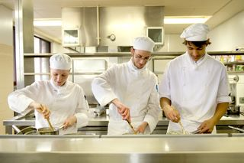
- Instructions for preliminary preparations
- Equipment required
- Quantity and name of ingredients
- Method of preparation
- Cooking temperature
- Cooking time
- Number of portions the recipe will produce.

The Standard Recipe
Standard recipes form the basis of the food control system and prescribe the ingredients and recipe for a menu item.
The main reasons for using standard recipes are to:
- Maintain a consistent quality of each dish – so quality and presentation is uniform regardless of who cooks the dish and regardless of when it is produced
- Establish the food cost for each menu item – so an appropriate selling price can be calculated to obtain the profit required by the venue/management
- Control the portion size – to make sure all customers receive the same size serve and ensure the recipe will serve the number of people it has been prepared for
- Establish the food cost percentage for each menu item – so the financial performance of the kitchen can be determined
- Write accurate food orders – to enable effective purchasing of ingredients
- Assist in the training of new staff – by providing the basis for demonstrations and practice.

Standard Recipe Cards
All the information needed to produce a standard recipe should be recorded on a standard recipe card.
Where a standard recipe exists for a menu item, they must be followed exactly.
A standard recipe card should contain the following details:
- Name of the menu item
- Section on the menu – entrée, main, desserts
- Recipe number
- Date costed
- Portion size
- Portion yield
- Portion cost
- Food cost percentage
- Selling price
- Ingredients list – listed in order of usage
- Quantity of ingredients
- Unit of ingredients – units of measurement for ingredients
- Unit cost – using invoices as source documents for this
- Total ingredient cost
- Total cost of item
- Production method in the correct sequence
- Photograph of finished product.
Location of recipes
Recipes, standard recipes and standard recipe cards may be located:
- In the Head Chef’s office
- In a folder or file in the workplace
- On the kitchen intranet.

Example of a Standard Recipe Card
ITEM | Oysters Mornay |  |  | PORTION SIZE |  |  | 1 Doz
SECTION | Entrée |  |  | PORTION YIELD |  |  | 1
RECIPE NO. | 12 |  |  | PORTION COST |  |  | $10.10
DATE COSTED | 09/06/20XX |  |  | FOOD COST |  |  | 40.4%
 |  |  |  | SELLING PRICE |  |  | $25.00
Ingredient | Qty | Unit | Cost/Unit |  | Total $ | Method
Oysters  Parmesan cheese  Parsley  Mornay sauce | 1  0.03  1  0.1 | Doz  Kg  Sprig  Lt | 9.00  7.80  2.50  3.60 |  | 9.00  0.24  0.50  0.36 | Remove oysters from shell & poach until cooked.  Wash shell & place on rock salt, opening facing upward.  Place oyster inside, sprinkle with cheese & gratinate under salamander.  Decorate with washed sprig of parsley & serve immediately.
Total Cost |  |  |  |  | $10.10
PHOTOGRAPH (of finished Oysters ready for presentation to customer)
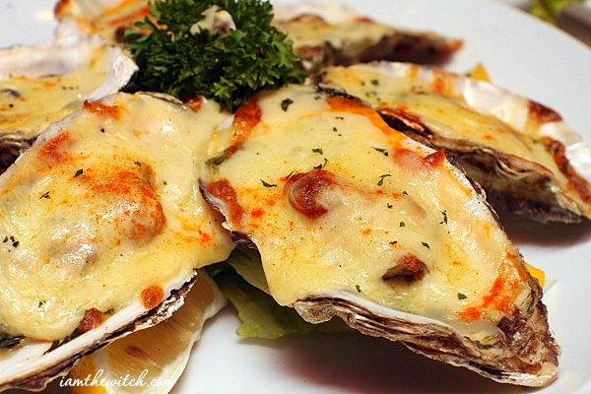

Calculating quantities required – relevant factors
Calculating quantities required for food items requires consideration of the factors listed below to determine level of expected demand as appropriate to the specific food production and service session:
- Review previous trade figures for same/similar events/service sessions – to identify historical data on amounts/volumes
- Talk to the client – to learn how many people they want you to cater for/the number of people they expect to attend a function (or are willing to pay for)

- Read any relevant contracted requirements – where you are catering for an event/function there will be a ‘function file’ detailing not only the agreed menu but also the numbers of guests
- Check the bookings – these are the advanced reservations which have been made and can indicate:
- How busy you are likely to be/numbers booked
- Special requests
- Know specific session information and venue requirements/preferences – for example:
- Hours the outlet is open – longer trading hours mean the potential for more food to be produced
- Maximum seating capacity of the room/outlet – this, when combined with a knowledge of bookings which have been made and/or previous trading data, indicates a context for the volumes required
- Style of service – à la carte, table d’hôte or buffet: more food is generally required for set menus and smorgasbords
- Understand operational protocols for the food outlet – these relate to a variety of issues such as:
- Number of sittings – number of times each seat is sold per session
- House policies as applicable – for example:
- Can food be prepared in bulk, in advance and held under refrigeration or in frozen storage for later re-heating?
- Is left-over food allowed to be stored for later re-use, or must it be thrown out?
- Are there other options for using/selling food produced for this session but which is not used in this session? For example, can left-over/unused menu items be transferred to another outlet in the venue and offered for sale there?
- Production capacity of the kitchen – there will always be limits on the volumes of food which can be produced due to constraints within each individual kitchen such as:
- Layout of the kitchen and equipment
- Amount and type of equipment available
- Skill levels/competency of staff.

Adjusting a recipe
Adjusting a recipe means altering the quantities of ingredients to allow you to produce more or less of a dish but retain the required flavour, appearance and profit.
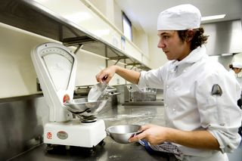
You may have a standard recipe for 50 portions of Chicken Marengo but only need to produce 20 serves.
Similarly your recipe may be for 50 serves but you may require 150 serves.
Special care needs to be taken when adjusting a recipe because mistakes can easily occur when calculating the new/revised quantities: there is no point getting nearly all of the calculations right, and messing up just one or two.
Sample calculations
Consider the above Chicken Marengo example where you wanted 20 serves from a recipe designed for 50: you want 20 out of 50 serves, which means you require 20/50 of the recipe, or 2/5ths of the quantities.
To express 2/5ths as a percentage (and this is preferable because percentages are easier to use), simply use the calculator as follows:
- 2 ÷ 5 = 0.4
- 0.4 x 100 = 40%.
This means if you multiply all the ingredients in the original 50-serve Chicken Marengo recipe by 40% you will arrive at the new amount of ingredients for the recipe for 20 serves.
Alternatively, say you have a recipe for one litre of Béchamel Sauce and you need three litres, simply multiply all the ingredients by three to get your new recipe.

More information
Visit the following sites for more information:
- http://thefoodsite.getphpbb.com/viewtopic.php?t=7&f=18
- http://www.google.com.au/search?q=standard+recipe+format+example&rlz=1I7GGLL_en&tbm=isch&tbo=u&source=univ&sa=X&ei=2QegUfj5Js2diAew54DABQ&ved=0CDkQsAQ&biw=1024&bih=630
- http://www.doe.sd.gov/cans/documents/CACFP_numbermemo_70_StndrdizdRecipes.pdf
- http://www.summerhockey.com/academe/recipecostingdirections.pdf
- http://extension.oregonstate.edu/catalog/4h/4-h93112.pdf.

1.3 Order products required from suppliers with specifications for products

Introduction
All venues need to order stock from suppliers to enable kitchens to produce the food on menus they have established.
This section considers the types of suppliers which may be used, presents different ordering/purchasing options, identifies descriptors of food requirements which need to be included when lodging food orders and introduces ‘food purchase specifications’.

Types of suppliers
All kitchens will deal with a variety of suppliers to obtain the food/ingredients they need in order to produce require dishes.
Wholesalers
Venues will normally deal with suppliers who are ‘wholesalers’.
Wholesalers are suppliers who sell to businesses/venues, and to retailers.
Wholesalers will/may:
- Usually understand the demands, problems of the industry
- Sell at prices which are lower than those offered by retailers
- Deliver the items ordered direct to the venue/kitchen
- Allow the venue to buy on credit – meaning payment does not need to be made at the time of purchase
- Operate under various conditions called their ‘Terms of Trade’ – addressing topics such as:
- Fees and charges – for delivery, insurance, re-packing
- Payment of accounts
- Handling of issues such as short-deliveries, out-of-stock products, damaged goods, complaints
- Require minimum quantities to be ordered before they will deliver or make a sale.
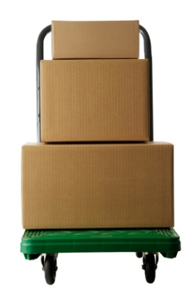
Retailers
Retailers sell direct to the public.
Their prices are usually more expensive than wholesalers and they do not (generally) offer the same services to venues that wholesalers do.
While venues will always prefer to deal with wholesalers the reality of kitchen life is there can often be a need to buy some food items from retailers (shops and supermarkets), for example in an emergency.

Wholesalers and retailers
Some suppliers operate as both wholesalers and retailers.
This means they sell to venues (at wholesale prices and under appropriate Terms of Trade) and they also offer a retail service to members of the public.
Preferred suppliers
Unless you are running your own business you rarely have the freedom to buy from whoever you want.
You usually have to buy from suppliers who have been approved by management – these suppliers may be known as ‘preferred suppliers’.
These suppliers tend to be businesses with whom your venue has an established relationship based on factors such as:

- Good/competitive prices
- Service levels – for example:
- Providing deliveries when required
- Handling discrepancies
- Resolving issues
- Range of products available
- Quality of items
- Beneficial Terms of Trade
- Continuity of supply
- Their physical location/proximity to your venue.
Classifications of suppliers
Kitchens will usually deal with suppliers in the following categories:
- General produce – this is a supplier who provides a wide range of proprietary (‘brand name’) foods such as:
- Dried goods/foods
- Refrigerated foods
- Frozen foods
- Bottled and canned/tinned food
- Ancillary items used in the kitchen – such as small equipment, utensils, crockery and cutlery, cleaning equipment and detergents/chemicals
- Butchers and poultry suppliers – who supply raw and processed meat.
- You may have one butcher/supplier who provides all your meat and poultry needs, or you may use a specialist butcher/provider for different types of meat (beef, lamb, pork, chicken, turkey)
- Baker – for bread, rolls and pastries
- Dairy – to provide milk, cream and prepared pastries
- Seafood supplier – providing fish and shellfish
- Greengrocer – providing fresh fruit and vegetables
- Specialist local suppliers – local businesses that grow, produce and/or supply a variety of niche/boutique products and ingredients.
Note
Many suppliers are able to provide multiple product types.
For example, the supplier of meat may also be able to supply poultry.

Background to ordering food
In relation to ordering food for a kitchen it is important to note:
- Different venues can use different options – not everyone orders the same way
- Not all suppliers offer all the purchasing options listed below – some only offer the basic options
- You should adhere to the standard purchasing options used by the kitchen/venue where you work
- Always follow house policies and protocols – which may require:
- Designated options to be used for nominated suppliers
- Specified documentation to be completed
- Certain authorisations to be obtained (signatures) prior to lodging an order
- Adherence to maximum purchase quantities
- Quotations to be obtained for purchases over a given value.

Purchasing options
There are a variety ways in which food may be ordered from suppliers.
Electronic ordering systems
This is a high-tech option where your computerised internal stock system ‘talks to’ the computer at the supplier’s business and automatically generates orders when pre-determined (minimum) stock levels have been reached.
This is not a commonly available option.
Telephone orders
This is probably the most common purchasing option given the short lead time which often applies to most food which needs to be ordered. That is, an order often needs to be placed after lunch for delivery same day, before the evening meal, or for delivery first thing next day.
The authorised person simply phones the supplier and places an order, identifying themselves either by name/address and/or by a prescribed password/code.
These phone orders may be followed-up by some form of documentation (Purchase Order), or may be stand alone orders with no accompanying paperwork.

Purchase Orders
A Purchase Order properly signed by the appropriate person provides the basis for delivering the goods listed on the document and charging for them. Some venues will insist no order is placed (or paid for) unless accompanied by an authorised Purchase Order.
Even in these businesses it is common for phone orders to be placed – and the order delivered – before the correct documentation is raised to ensure foods are delivered on time/when needed.
The supplier may have their own pre-printed order forms, which may be part of a Catalogue/Price List, given to you to assist in this process.
Alternatively, the venue may have their own printed Purchase Orders which require an authorised signature of the Head Chef, owner or manager before they are deemed to be valid.
Face-to-face orders
Some suppliers have employees (‘sales representatives’) who call on businesses to build rapport, advise on new products, inform you of Special Deals and take orders.
These orders may be accompanied by an authorised Purchase Order or simply be one-off orders given verbally.

On-line ordering
This increasingly common option combines the benefits of Purchase Orders with the speed of the telephone as well as allowing you to place an order with suppliers who offer this facility at any time on any day.
Venues/kitchens are allocated an Outlet Number and Password to facilitate their Login to the online system and to ensure only they can place orders for their venue.
Known as e-purchasing.
Faxing orders through
This has similar benefits to ordering on-line.
Where purchase orders are used the fax machine may be the preferred method of lodging orders as it allows orders to be placed at any time and enables proof the order has been placed.
Standing orders
In some cases, such as with the bakery and dairy supplier, it is possible to arrange for standing orders to be implemented.
A standing order is one that is activated on a regular basis as arranged.
For instance, you may have a standing order with the bakery to deliver 6 dozen bread rolls every weekday. You may have a standing order with the dairy to deliver 20 litres of milk every Monday, Wednesday and Friday.
These standing orders are automatically delivered as arranged without the need to actually place an order. They may be increased or decreased as trade requires, and they may even be cancelled where necessary by making a phone call to the supplier.


Information to be provided when ordering food
When ordering food you need to provide:
- Sufficient detail of each product required to enable the supplier to accurately fill the order
- Business information and delivery details.
Sufficient details of each product
Information you need to give to the supplier will vary depending on whether the item is raw, fresh or processed.
In all cases a combination of the descriptors/details presented below will need to be used, for example:
- Description of the item – as follows:
- Meat and poultry – by animal type, age and cut
- Fruit and vegetables – by type, variety and grade/quality
- Packaged, processed and pre-prepared food – by type, variety, brand name and unique product descriptors/identifiers
- Amount and size of each item required – the way to describe this will vary depending on the item/ingredient with options being:
- By quantity, number or units – ‘six 750 ml bottles’; ‘2 cartons’; 6 x 1 kg bags’
- By weight – ‘10 kg A grade beef mince’; ‘500 gm South Sea rock salt’
- By volume – ’2 x 10 litres full cream milk’; ’500 ml Dairy Fresh sour cream’.
Business information and delivery details
You will/may also need to provide:
- The name of your venue
- The trading name of the business
- Your name
- Details of any password or code which identifies you and confirms the order being placed is a legitimate one
- When the delivery is required – by day/date and time of day
- Address for delivery – including specific location within the venue (for example, ‘Main store’, ‘Main kitchen’, ‘International bistro’).

Food purchase specifications
Use of food purchase specifications
Food purchase specifications (also simply known as ‘food specifications’) are used by venues to inform suppliers regarding the quality and standards required of the food they must deliver.
Some venues use food purchase specifications.

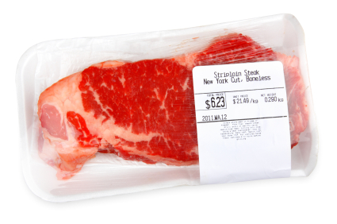
They are commonly used by:
- Hospitals and aged care facilities
- Fast food franchises
- Big operations that purchase large volumes of particular items.
Many suppliers do not operate on the basis of purchase specifications – they supply products as in their catalogue/price list.
Reasons to use food specifications
Venues/kitchens develop and use food specifications to specify the food they require in order to:
- Maintain the standard and quality of the food they produce – the standard/quality of menu items relates directly to the standard/quality of the base ingredients
- Control/define the quality of certain ingredients bought from suppliers – to help ensure their suitability for their anticipated use: allowing you to define lesser/lower quality and hence cheaper ingredients where their final use enables their use without adversely impacting on quality. For example, many wet dishes can be quite adequately produced using less than optimum quality vegetables, where this is not the case with vegetables to be used in salads or sandwich fillings
- Eliminate doubt about what is required – using food specifications gives certainty about what is needed and removes uncertainty
- Save labour – where the specification sets out (for example) the trim requirements of meat, and the need for cuts of meat to be sliced into certain thicknesses/weights this saves kitchen staff having to spend time undertaking these basic food preparation activities
- Form a standard basis on which to undertake competitive tendering – by ensuring all tenderers are quoting for the same product
- Provide an objective and standard framework for inspecting food – on delivery to the venue
- Give certainty regarding financial matters – in relation to cost prices.
Contents of food specifications
Specifications will differ depending on the food being specified.
For example the details contained in a food specification for legs of lamb will differ markedly to requirements for fillets of fish, a certain variety of lettuce or whole chickens.
This understood, standard product specification information can include:
- Product name
- Product category – convenience, frozen, fresh, refrigerated
- Quality specifications such as:
- Colour
- Count
- Texture
- Unit size
- Shape
- Thickness
- Trim
- Tolerances
- Grade
- Weight and yield data
- Packing format – such as number of tins per carton; dimensions of cartons
- Nutritional content/requirements
- Required labelling data
- Brand name – where applicable
- Photograph or graphic/diagram of what is required
- Variety – where applicable
- Storage requirements
- What the product/item is to be used for
- Special instructions or requirements – this can relate to the delivery of the product, product sampling, product testing, and/or storage
- Substitute product
- Maximum cost price – per unit/item or other specified measure
- Temperature at which item is to be delivered.
A wide range of examples of food purchase specifications are available at:
http://www.google.com.au/search?q=photos+food+purchase+specifications&rlz=1I7GGLL_en&tbm=isch&tbo=u&source=univ&sa=X&ei=7JShUanCK7CSiQf82YHYCw&ved=0CD0QsAQ&biw=1024&bih=630&sei=9ZShUdTzCqvyiAep5oC4Aw.

More information
Visit the following sites for more information:
- http://www.hotelschool.cornell.edu/research/chr/pubs/reports/abstract-15779.html
- https://www.aibonline.org/researchandtechnical/services/foodlabeling/ExampleProductSpecificationSheet.pdf
- http://learning.covcollege.ac.uk/content/NLN/Catering,_Food,_Leisure_Services,_Tourism/Hotel,_Catering_(General)/act_NA11_purchasing/150a_purchase_spec.htm
- http://www.nfsmi.org/documentlibraryfiles/PDF/20080208045545.pdf.

1.4 Prepare production sheets/work schedules

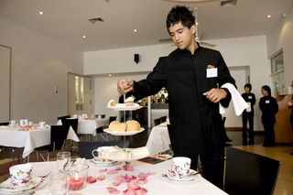
Introduction
Some kitchens develop production sheets/work schedules as part of their standard planning activities prior to a food production/service session.
This section discusses the role of production sheets/work schedules and describes their use.

The role of production sheets/work schedules
Not all venues/kitchens use production sheets/work schedules and where they are used there is a significant variation in the format and the information they contain.
If/where they are used they should be prepared daily for each food production/service session.
In brief, a production sheet/work schedule sets food production targets for the session.
A production sheet/work schedule identifies for each session/day:
- Menu items (by name) which have to be prepared – identification may address (depending on the format of the sheet/ schedule):
- Mise en place requirements
- Finished products
- Every menu item listed should have a corresponding standard recipe
- Some operators will attach a copy of these standard recipes to the production sheet/work schedule when distributing them to staff
- Quantity to be produced
- The kitchen section responsible for the work to be done
- Start time for preparation/production
- Time each menu item is required.

Use of production sheets/work schedules
Production sheets/work schedules are used to:
- Force management/chefs to plan the production of food – so attention is paid to ensuring all identified requirements are met
- Provide a basis for ordering food required – ensuring food orders only reflect identified need thereby avoiding over-ordering of unnecessary ingredients
- Assist the communication between management/chefs and other kitchen staff – by providing certainty about what is required through the use of paper-based directions
- The production sheet/work schedule is distributed and discussed at the staff briefing at the start of each shift/session
- Form a vital element of developing work flow sheets for each food production sessions/shifts – see section 2.1.
- Guide and control the production of food:
- For immediate service/consumption
- Which is to be refrigerated or frozen for later use/re-thermalisation.

More information
Visit the following sites for more information:
http://books.google.com.au/books?id=ohMwXgsCcaQC&pg=PT172&lpg=PT172&dq=define:+production+sheet%2Bkitchen&source=bl&ots=IbN5U2tE3-&sig=0ydAkAv0cP9MCSA_rJoa7Evi0qs&hl=en&sa=X&ei=aKWiUdnhBejOiAfbu4CoCA&ved=0CDMQ6AEwAQ

Work Projects
It is a requirement of this Unit you complete Work Projects as advised by your Trainer. You must submit documentation, suitable evidence or other relevant proof of completion of the project to your Trainer by the agreed date.
1.1 In order to complete the requirements of this Work Project you are required to:
- Identify and describe a particular event/occasion – including date, time, numbers attending/expected and relevant constraints, requirements and specific requests
- Develop an appropriate menu for this event/occasion
- Develop standard recipes for three dishes on the menu
- Determine quantities required for food items as per the three standard recipes
- Write a purchase order for the ingredients required to produce the three menu items (above)
- Prepare production sheet/work schedule for the menu which has been developed.

Summary

Plan for food service production
When planning for food service production:
Develop the menu to accommodate all known venue requirements and customer requests
Consult with others when planning the menu
Determine service requirements as part of the menu planning process
Create/use standard recipes
Calculate quantities of ingredients needed to produce the amount and type of food required
Order food/ingredients from suppliers adhering to established internal restrictions and operational protocols
Use food purchase specifications (where appropriate) to assist in the food ordering process
Generate and share a production sheet/work schedule for each session to facilitate food production.

Element 2:
Prepare and produce food items for food service

2.1 Identify and plan work flow

Introduction
Actual preparation and production of food items for a service session should be based on planning.
This section defines the work flow sheet (‘work plan’) in the context of kitchen operations, lists reasons work flow sheets are used and provides advice regarding their development.

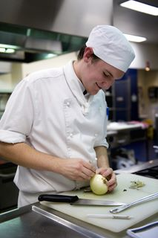
Defining work flow sheets/work plans
A work flow sheet/work plan is an action plan for the session and is:
- A sequential list of all the tasks which need to be done for a specific food production/service session
- A series of timelines identifying when activities should start and the time they need to be completed in order to achieve the required outcomes for the session
- An allocation of tasks/work to individual staff and/or sections.
Work flow sheets are often referred to as ‘work plans’.

Reasons to use work flow sheets/work plans
Kitchens develop work flow sheets/work plans to:
- Help ensure all necessary food preparation and production work for a service session can be completed as required to enable timely food service
- Integrate the wide variety of kitchen activities into a cohesive whole
- Allocate work to nominated kitchen sections and/or employees
- Optimise efficiency and productivity
- Schedule and prioritise work necessary to achieve the required outcomes for the session
- Verify the required work can be completed in the time available
- Identify potential problems with timing and sequencing of food preparation and production activities and requirements.

Preparing work flow sheets/work plans
Not all kitchens prepare or use work flow sheets/work plans.
Some kitchens operate effectively on the basis of verbal advice/instructions given to staff by the Head Chef at a staff briefing prior to the commencement of work.
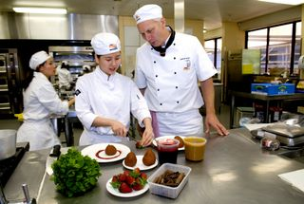
Where work flow sheets/work plans are prepared the following factors should be considered:
- Watch more experienced staff prepare work flow sheets before you prepare your first examples – ask them why they planned the way they did and what they took to account
- Learn from their experience, and ask them to review your initial attempts
- You should prepare the sheets by ‘working backwards’ – that is, you begin with the service times for dishes/meals and calculate the time needed to prepare/produce menu items working backwards to determine when tasks need to commence in order to complete work ‘on time’
- All components of all dishes listed on the menu for the session must be covered by the plan/work flow sheet – this includes preparation of freshly made/cooked food as well as re-constitution/re-heating of previously cooked food (see ‘production sheets/work schedules’, section 1.4)
- Realise you will rarely create a viable work flow sheet on your first attempt – effective work flow sheets are usually the result of many drafts and revisions/fine tuning
- The venue may have a standard template for developing work flow sheets – or they may be created ‘free-hand’
- The roster for the service session must form the basis of the work flow sheet – development of the work flow sheet may indicate the need for more labour but this can only occur with management approval/if there will be no adverse impact on labour cost percentages
- Identified roles and responsibilities of staff and sections together with known experience and expertise must be the basis of allocating work
- They should be distributed to/shared with staff – prior to work commencing, at the staff briefing
- Use your experience with previous work flow sheets you have developed (‘lessons learned’) to assist with the preparation of subsequent sheets
- Develop every work flow sheet so as to:
- Meet the needs of the individual/up-coming session – you have to take into account factors that apply to each session: it is inadvisable to try to create generic work flow sheet
- Avoid production bottle-necks – that is:
- Do not over-load individual staff or sections
- Avoid placing too much demand at the one time on the one item of equipment

- Identify the resources to be used/available for each task – in terms of (for example):
- Staff
- Equipment
- Recipes
- Include/specify constraints or required parameters which apply to the activity – such as (for example):
- Time
- Special requests/requirements – to cater for nominated dietary, cultural, religious or other lifestyle food preferences
- File all work flow sheets – so they are available for future reference.

2.2 Communicate with production team

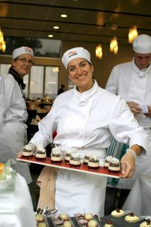
Introduction
Effective communication is a vital pre-requisite in any successful kitchen.
This section discusses the context of communication in a kitchen, identifies communication options, presents important aspects of communication and describes common topics for kitchen communication.

Context of communication
The production team
The ‘Production team’ is anyone involved in preparing, producing and plating food as well as those who support those activities such as staff engaged in:
- Purchasing, receiving, storing and issuing food
- Cleaning food areas and equipment
- Washing crockery, cutlery, pots and pans.
Need for communication
In a kitchen there is a need for scheduled communication and on-going communication.
Scheduled communication is regular communication such as:
- Briefings with staff – before work/shifts commence
- De-briefings with staff – after the service/production session
- Staff meetings – weekly/monthly ‘all of staff’ sessions.
On-going communication occurs during the shift/session and may involve:
- Up-dates regarding changes to plans/requirements previously notified – due to (for example) unexpected demand, equipment breakdown or changes to arrangements requested by customers
- On-the-job coaching – to provide practical training
- General supervisory/management activities – such as responding to questions, monitoring work, providing advice, guidance and direction
- Feedback – about progress, work which has been completed and customer satisfaction levels (‘complaints and compliments’)
- Recognition for work which has been done – thanking and acknowledging staff for the job they have done.

Communication options
In the kitchen two types of communication are commonly used – written communication, and verbal communication.
Written communication includes paper-based and electronic information:
- SOPs/work instructions – setting out procedures and protocols
- Checklists
- Production sheets/work schedules
- Rosters and time sheets
- Work flow sheets
- Standard recipes
- Food purchasing specifications.
Verbal communication is spoken language (directions, advice, orders, questions and other) supplemented by body language/non-verbal communication.
The fact the kitchen can often be a noisy and hectic environment has given rise to the use of a range of hand signals to support and/or replace verbal communication in some instances.

Important aspects of communication
In relation to communication it is vital to realise the following important points:
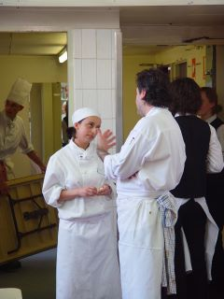
- Communication is a two-way process – ‘feedback’ is the critical element that completes the communication process by turning a monologue into a dialogue:
- Just because you have spoken to a staff member does not mean they have heard you – or will respond as you want or expect them to
- Just because you have given staff written information does not mean they have read it or understood it – or will implement what is required
- There is a need to create a working environment where there is free, open, honest and timely communication – this is the single biggest challenge facing all kitchens
- Many staff need to be encouraged to communicate because they are unfamiliar and/or uncomfortable with a work situation where their opinion is valued or actively sought
- Many kitchens employ workers from different language backgrounds and with varying levels of language skills – not all staff will necessarily speak your language or the same language
- Written communication may need to be provided in more than one language
- Verbal communication may need to be given in different languages for it to have optimal effectiveness
- There are often barriers to communication (other than language) in the kitchen and these must be accommodated – examples include noise, distraction of work, need to concentrate on tasks, workers blocking views.

Common topics for kitchen communication
In a kitchen environment communication will often relate to:
- Allocated tasks – for individual staff and sections with (for example) emphasis on:
- Sequencing
- Priorities
- Resources available
- Standards and quality
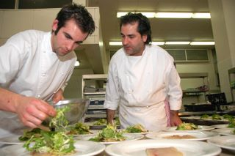
- Timing requirements – which can refer to:
- Service times
- Up-dates regarding delays and/or changes to planned service times/schedules
- Delays with expected delivery of goods-in
- Food orders – received from wait staff/servers including:
- Dish numbers
- Timing of service
- Special requests from individual customers
- Service protocols – in relation to:
- Service styles
- Plating requirements
- Timing
- Responses to complaints – and other situations requiring service recovery.

More information
Visit the following sites for more information:
- http://smallbusiness.chron.com/examples-communicate-kitchen-38303.html
- http://thestudentmenu.com/how-communication-works-in-a-restaurant-kitchen/
- http://www.chef2chef.net/culinary-student-blogs/communication-breakdown.html.
Work Projects
It is a requirement of this Unit you complete Work Projects as advised by your Trainer. You must submit documentation, suitable evidence or other relevant proof of completion of the project to your Trainer by the agreed date.
2.1 In order to complete the requirements of this Work Project you are required to:
- Plan a work flow (prepare a work plan) for a given food production session
- Describe the type and content of the communication necessary to implement the work plan for the given situation.

Summary

Prepare and produce food items for food service
When preparing and producing food items for food service:
Prepare a work flow sheet/work plan for every session
Share/communicate the work flow sheet/work plan with staff
Hold staff briefings at the start of every shift/food production session
Ensure work flow sheets/work plans reflect production sheet/work schedule targets
Realise service time is the key criterion when preparing plans and producing food – work backwards from the required service time to determine starting times for tasks
Obtain assistance when developing your first work flow sheets/work plans
Strive to meet all internally and externally imposed requirements/requests
Communicate effectively with others
Understand the kitchen can be a difficult communication environment
Accept feedback is necessary for true communication to occur.

Element 3:
Set up kitchen for food service

3.1 Place personnel ready for service

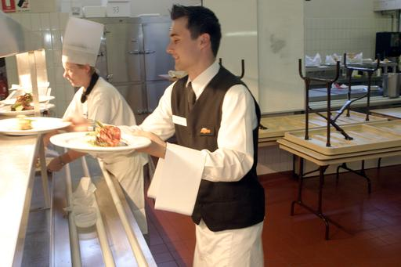
Introduction
An important part of setting up the kitchen for service is the placement of personnel ready for service.
This section defines ‘plating’ and ‘the pass’, discusses the allocation of staff to the serving/plating process, highlights the importance of consistency when plating and presents a range of standard plating requirements and considerations.

Plating
Plating is the act of putting food onto service platforms (mainly plates and bowls [see next section]) ready for:
- Collection by service staff
- Service to customers.

The pass
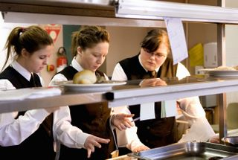
The ‘pass’ is a location in the kitchen:
- Where wait staff give their food orders to the kitchen
- Where plated meals which have been checked are given to wait staff for service to customers.
In relation to the ‘pass’:
- It physically separates the kitchen area from the dining area
- It is under the control of a designated Chef – who has absolute control over:
- Taking orders from wait staff
- Coordinating production and plating of meals to meet orders which have placed
- Final checks on dishes to approve and release them for service.

Allocation of staff to the serving/plating process
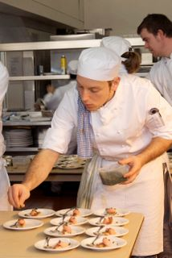
Allocation of staff ready for service must address the following points:
- Staff must have been trained in how to correctly plate dishes in accordance with house requirements – it is important the overall appearance of menu items (and the image and reputation of the venue) is not damaged by poor/sloppy presentation
- Staff must be given specific duties – they must be advised (for example and as appropriate to the menu and service style):
- Of the menu items they have responsibility for – that is, specified dishes being produced for the service
- About the individual food items they have responsibility for – that is, some staff will/may have responsibility for putting meat on the plate, some will/may have responsibility for plating vegetables and others will/may have responsibility for adding the sauce and garnish
- Staff must be physically located in positions which will best facilitate the optimum service of food for each session – this can vary between sessions and with changes in menus and service styles
- Staff who are allocated plating duties should be relived of other duties for the duration of the plating work – to allow them to focus on the job, and to avoid the potential for cross contamination (transferring germs/food poisoning bacteria from other tasks to plates and/or food)
- Sufficient staff must be allocated – to enable prompt plating of dishes once they are ready for service
- Staff must be allocated to support the staff who are plating the meals – attention must be paid to ensuring staff are available to:
- Fetch and carry – food and other requirements to the plating area
- Clean dirty/used plates returning from the dining area – to ensure an on-going supply of clean plates for service
- Prepare additional items as required during service – such as those which have run out during service including garnishes, sauces, butters, vegetables and salads and/or to meet special customer requests.

Importance of consistent appearance of menu items
It is important to produce a consistent appearance of menu items when plating for the following reasons:
- So dishes of the same type look the same – so customers do not think their meal is different to that of others
- To meet advertised descriptions of the dish – which may be described on menus or by photographs
- To ensure customers receive what they pay for
- To underpin the value-for-money represented by the dish
- To support portion control guidelines
- To create and meet guest expectations.

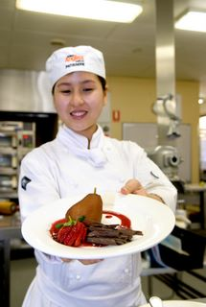
Standard plating requirements and considerations
When plating food, care and attention must be paid to ensure the meals are plated:
- Reproducing consistent quality product
- Neatly and attractively – to be visually appealing (see ‘Neat and attractive plating’ below)
- In compliance with any advertising/marketing undertaken for the venue and/or specific meals/menu items
- Without spills or drips – see ‘Spills or drips’ below
- To enterprise quality, and other, standards in-keeping with the requirements for the specific dish – see ‘Quality and other presentation standards’ below
- Taking into consideration:
- Eye appeal
- Colour and contrast
- Temperature of food and service style and equipment
- Classical and innovative arrangement styles.
Poor presentation standards and practices can ruin hours of work and lots of effort.
It can greatly reduce customer enjoyment of the meal, and lower the appreciation of the dining experience and the overall impression of the business.
Poor food presentation can adversely affect repeat and referral business.
You must always consider that customers eat with their eyes – they see the food before they eat it and this stimulates the appetite.
The way in which you plate and present food must entice, inspire and tempt customers.
Neat and attractive plating
All dishes must be served neatly and attractively.
During a service period, the Head or Sous Chef will usually check this occurs for each and every dish before it leaves the kitchen.
Plating considerations include:
- All dishes of the same type must look identical – in terms of serve size, number of items, layout of the dish components, where the garnish is placed, where and how the sauce has been served
- Photographs of model dishes or menu cards, must be observed
- The correct sized plate/dish must be used to complement the meal
- The same service plate/dish must be used for all the same menu items
- Balance must be achieved:
- This is the overall impression created by the look of the meal – there may, indeed, be some focal visual point to the dish. Some dishes have their appearance on the plate planned with as much care and thought as went into creating the recipe for the item
- It takes into account the precise placement of different shaped and sized items on the plate to create a balanced appearance rather than an unequal or uneven impression
- It also means balancing food textures rather than having a dominance of one texture to the absence of any other
- It means not over-doing a certain element of the presentation – often the garnish is overdone so you must be alert to guard against this.
- A final visual inspection of the meal must be made before it is released from the kitchen.
Spills or drips
The final touches to a dish before it leaves the kitchen must be to remove:
- Any sign of drips or spills, spots, or run marks
- Any smudges caused by removing drips or spills
- Any finger marks that may be the plate.
This consideration may also extend to inspecting the precision with which sauces may have been added and rejecting or re-doing any plates not meeting the required presentation standard.
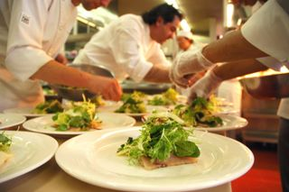
Quality and other presentation standards
A food business must first have standards set in place and these standards must be communicated to the staff.
Training and briefing sessions and the use of colour photographs are the most common methods of demonstrating the required business standards.
These standards may include:
- Where foods are placed upon the plate
- Where garnishes are added or placed
- Making sure dishes are plated within designated timeframes
- Ensuring the correct temperature of plates and other service ware
- Ensuring special customer requests are being met.
Eye appeal
All of the previously described points relate to the final eye appeal of the dish.
The design and layout of a dish can be a very memorable part of the meal.
Eye appeal, however, needs to be kept in context.
In some food establishments the need for good, wholesome food served quickly and priced competitively will outstrip the demand for excellence in visual appearance.
In these situations there may be the need for compromises on the basis of cost, speed of service and the identified preferences of customers.

Colour and contrast
Consideration of colours must be factored into the presentation of any dish or menu item.
Food colours must always be balanced and harmonised.
It is important the plate is arranged so similar colours do not come together as this can make the meal look dull and unattractive.
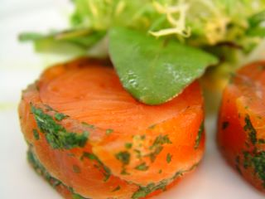
Using a coloured diagram or photograph of the menu item will help you to guide the positioning of different coloured foods.
A colourful garnish can lift the presentation of a meal but care must be taken not to over garnish or allow the garnish to overwhelm the main components of the dish.
Height and depth
Giving food height increases the overall presentation and can give the impression the portion is a little larger than it actually is.
Height can be achieved by stacking food, placement on top of other food items of using a tall garnish, such as a tuille biscuit.
Care must be taken as the food item may ‘topple’ over as it is being carried to the table. In some instances, whilst height may make some foods look more appealing, it may have an adverse effect insofar as it may be difficult to eat. An example of this may be an overly filled sandwich or burger.
Depth can be given to a dish simply by using clever placement of components of a menu item.
Placing the taller component to the rear of the plate and having other components ‘tapering’ down toward the front can give the impression of depth, adding an interesting characteristic to the dish.
The same principle is usually applied to buffet service where certain items are placed at different heights and levels on the buffet table. Sometimes, ‘props’ such as tall vases are used to give depth to the presentation of buffet items.

Impact of plating on customer perception of the organisation
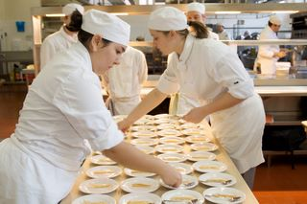
The correct plating of food combines with many other factors in creating a customer’s perception of the venue where they are dining and is an extremely influential element.
Customers will infer many things about the venue from the way their food looks when it is served so the way the food looks on the plate sends a range of messages to customers about the venue such as:
- Its professionalism
- The care and attention it pays to food and products
- Food safety
- Product quality.
Customer perception is also generated by other factors such as:
- Prices charged and value-for=money
- Décor and ambience
- Service levels and standards
- Location and facilities
- Range of choice and options available.

More information
Visit the following sites for more information:
- http://www.peppers.com.au/food/food-preparation-plating-up-tips-video/
- http://www.youtube.com/watch?v=Gy8-SKIm4Fs
- http://www.youtube.com/watch?v=Cbn2aedc8wEhttp://videos.howstuffworks.com/discovery/13870-inner-chef-plating-your-food-video.htm.

3.2 Allocate equipment

Introduction
In addition to allocating/placing staff for food service it is also essential to ensure the correct equipment and utensils are provided to support and enable the plating process.
This section identifies and discusses a variety of food service/plating and food display options.

Service equipment and platforms
Service equipment and service platforms are items used in the plating and decorating and display of food items.
It is important to have all service equipment available and ready before service starts.
This includes equipment for lifting, pouring, portioning and general handling of all food items to be served.
For food safety reasons, food handler’s gloves must be worn if hands are to be used to effectively position food items on a service platform.
Basic requirements for service equipment
Service equipment must be:
- In good condition
- Clean and sanitised
- Free of chips or cracks
- Sufficient in number – a standard protocol to help prevent colour and flavour transfer is the one service item or utensil is only used to serve the one item/type of food
- Food grade standard – meaning they will not contaminate or discolour the food items being plated or presented.
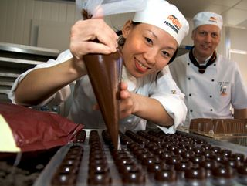
Tables and bench space
Tables and bench space needs to be allocated for the plating/service process.
Requirements for this space include:
- The area must be cleaned and sanitised immediately before use – to help prevent food poisoning/cross contamination
- Once in use as a plating area it should be dedicated solely to service of food – and not used for anything else
- No coughing or sneezing over the surface – or foods or plates on the tables/benches
- No eating of food over these surfaces – to guard against crumbs/food dropping in to other food/food for service to customers
- Spills on these areas/surfaces should be cleaned immediately – for food hygiene/safety reasons and to prevent the spread of marks on plates.
Examples of service items/utensils
The following may be used for service:
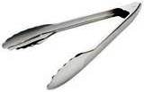  Tongs | 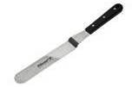  Palette knife
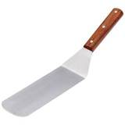  Kitchen spatula | 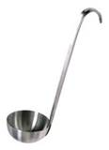  Ladle
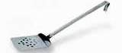  Egg slide/lifter | 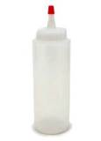  Squeeze bottle
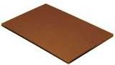  Cutting/chopping board | 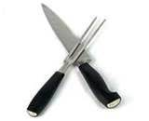  Carving knife and fork
In addition it may be necessary to provide (for either kitchen staff and/or dining room/wait staff) items such as:
- Service trolleys and trays
- Cake lifters
- Heat cloths.

Utensils used for serving and portion controlling
The items below assist with serving food and controlling portion size:
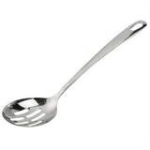  Serving spoon |   Soup ladle
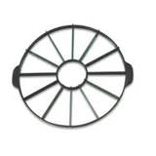  Cake portion guide | 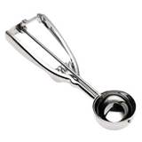  Ice cream scoop
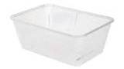  Plastic tubs | 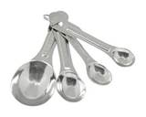  Measuring spoons
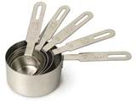  Measuring cups | 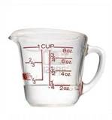  Measuring jugs
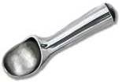
Scoop

Service platforms
Service platforms are items used as a base for food presentation.
Serving plates and bowls
Traditionally, these types of service ware are round or oval in shape. Modern trends now see more innovative items in a variety of shapes being used. This makes the overall presentation of food more visually interesting.
Many plates used in modern dining include rectangle, triangle, staggered and off centre shapes and styles.
Commonly, service ware is ceramic; however some innovative chefs use items such as slate and highly polished wood to add a different dimension to food presentation.
The traditional colour for plates and bowls is white. This neutral colour forms a clean base to allow the natural colours of the food presented to stand out.
Depending on the food being presented, other base colours such as black or red are sometimes used.
Colours or designs that are ‘busy’ or have intricate design patterns are not recommended as they will usually detract from the food being presented.
Examples of plates and bowls
  Main course plate |   Entrée plate |   Side plate
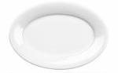  Oval plate | 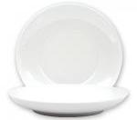  Deep plate | 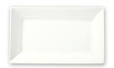  Rectangular plate
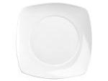  Rounded square plate | 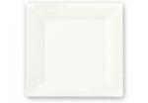  Square plate |   Triangular plate
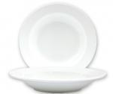  Soup/pasta bowl | 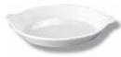  Gratin dish | 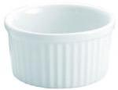  Ramekin/soufflé dish
  Glass cake plate | 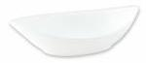  Oval point bowl | 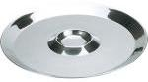  Oyster plate
Innovative service platforms
These are used by chefs who are seeking something different in the way that their food is presented. Some are altogether new and inventive; others are sometimes a new ‘twist’ on the culture or tradition of different cuisines.
If looking for a new or innovative way to present food, you must consider:
- If the item is practical – may be too thick, too heavy
- If the item is hygienic and food safe
- If the item is non-porous – can hold water/moisture.
  Slate tile | 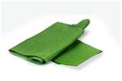  Banana leaf | 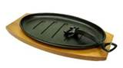  Sizzle plate
Display service platforms
These are items used for the presentation of food on a larger scale, such as for buffets.
Many of these items are used to add height and depth to a buffet layout.
Polished silver or stainless steel adds elegance to the overall presentation of a buffet.

Platters and stands
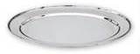  Oval platter | 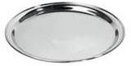  Round salver | 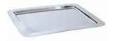  Rectangular platter
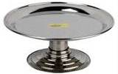  Cake stand | 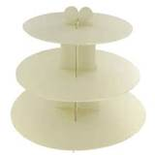  3 tier stand | 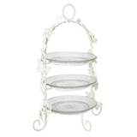  Decorative tier stand
Props
These are items which complement food displays and can enhance a particular theme.
They may also add a different dimension to the layout of a buffet, creating an interesting visual display.
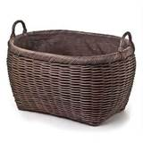  Woven basket | 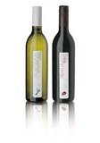  Wine bottles | 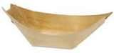  Wooden boat
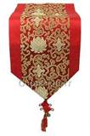  Table runners |   Artificial plants

3.3 Determine service style to suit operation

Introduction
A service style need to be selected for every food service session which best suits the needs of the operation and (where applicable) the needs, wants and preferences of the customer.
This section discusses factors impacting on the selection of service styles and provides an overview of several popular service styles which can be chosen to best suit operational requirements.

Factors impacting selection of service style
The following factors will impact on, or determine the selection of, the service style for a specific meal:
- Time of day/service period (breakfast, lunch, dinner, supper)
- Occasion
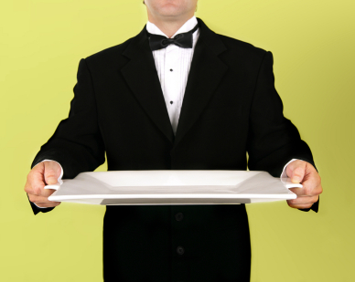
- Number of courses
- Time constraints
- Other activities – such as speeches
- Customer, client or host preferences
- Number of guests dining together
- Desired cuisine style
- Menu style – see immediately below.

Popular service styles
The service style will need to reflect the style of menu which has been produced.
A la carte/plated service
A la carte service involves customers ordering dishes from an extensive menu. This style of service allows/requires food to be cooked to order, usually for small groups of customers arriving and dining at different times.
Courses on an à la carte menu include; appetiser, entrée, main course and dessert.
Each kitchen section will prepare and cook different elements of the menu and will have different set up requirements in relation to food, equipment and service ware.
A la carte food presentation is usually the most detailed in presentation and menu items may have many elements.
Menu components are generally of high quality and many, such as vegetables, starches and garnishes are par cooked to assist with faster cooking and service.
Completed/plated meals and their components are sent to the ‘pass’ where the senior Chef will quality check and may add final touches such as sauces and garnishes to the dishes before sending them out to the diners.
The same style of service applies to the service of table d’hôte menus.
Plated service of meals is also referred to as à l’anglaise.
Function service
In function service, customers have a limited menu choice.
This style of service is usually delivered for large functions, such as weddings and birthday parties, where the guests are usually seated and the group is served the same course at the same time.
There are normally only three or four courses served on a banquet menu – appetiser, entrée, main course and dessert.
There are usually only two or three menu choices for each course.
Service set up for banqueting usually involves menu components being precooked (hot meals) trayed up, re-thermalised and stored in heated units sometimes referred to as ‘hot boxes’.
Service staff form a ‘line’ and each person is responsible for placing one or two food components on the plate as it is passed along a plating table. This repetitive style of plating usually ensures consistency of plating and presentation.
A senior Chef will usually service the end of the line for final inspection, quality control and cleaning drips or spills.
Meals not meeting the required uniform standard of presentation are rejected.
Buffet service
Buffet service entails the layout and display of hot and cold food items. Generally customers serve themselves from a wide variety of displayed menu items.
In some instances, foods may be portioned and plated by service staff, such as at a carving station for roast meats or service of wet dishes and other items from Bain Maries. This assists with portion control and observation of food hygiene procedures.
Sections of the buffet may include; appetisers, entrees, soups, wet and dry main courses, carved roast meats, sauces, vegetables, rice and pasta dishes, salads and desserts.
Aside from decorating and garnishing individual food items, a buffet layout may also be decorated with other items to enhance the overall presentation and create a ‘spectacle’ for the customers.
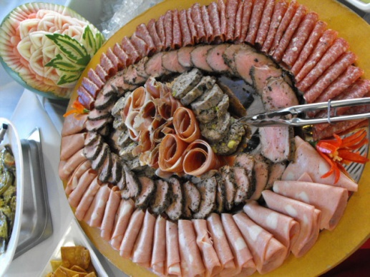
Buffet centrepieces can include:
- Flower arrangements
- Decorated centrepieces
- Ice carving
- Margarine models
- Chocolate and marzipan models
- Themed furnishings and props
- Themed ingredients or items
- Carved fruits and vegetables
- Fruit and vegetable baskets
- Props such as vases and artificial plants.
A buffet may be prepared for any service period at the request of the customer or client. This can include breakfast, lunch, dinner and supper.
Large hotels usually serve a buffet breakfast as this frees the kitchen for preparation of menu items for an à la carte lunch and dinner service.
Food for buffets is usually placed neatly into trays or onto plates and platters then garnished.
Hot items may be kept in a Bain Marie or chafing dishes and cold items in a salad well, open display chiller or on ice.
During buffet service, staff should ensure that emptied or unattractive food containers are removed and these are replaced with fresh items.
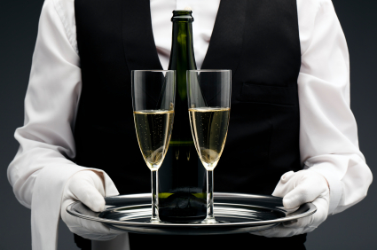
It is also important to continually replace unclean service utensils such as tongs, spoons and ladles with clean ones.
Stand-up service
Some functions/events require catering to be provided in stand-up form.
This is an option where guests stand-up to eat and drink as opposed to being seated at tables.
For stand-up menus:
- The menu items will feature finger food – small/bite-size food which can be eaten using the fingers instead of traditionally cutlery
- Forks and toothpicks are provided – for some foods to assist with their consumption
- Food may be placed on central/common tables – where guests help//serve themselves
- Food is served/presented using platters, bowls and trays – with side plates and serviettes required for guests
- Wait staff may circulate among guests offering food – clearing used plates and replenishing foods as required.
Family service
This style of service is where dishes are placed in the middle of the guests’ table and the guests help/serve themselves.
Service requires:
- Suitable shape, style and size/s of serving dishes – for placement of menu items onto the table
- Serving spoons, ladles or tongs – suitable for the menu items served
- Placement of guests crockery and cutlery onto the table before the food is served to the table – so guests may begin serving themselves as soon as the food is delivered to the table
- Attention to portioning of food – to ensure there is sufficient food served to cater for the number of guests at the table.
Gueridon service
This is a fine dining option where food is tableside service/cookery.
Gueridon service can include the cooking of dishes at the table, the creation of salads in front of guests, the completion of dishes at the table which were started (pre-prepared) in the kitchen and the ‘flambéing’ of dishes at the table.
Gueridon service requires:
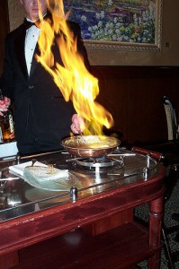
- Specialist equipment to deliver the tableside service – such as gueridon trolleys, burners, pans and service equipment
- High level skills for service staff – cooking, showmanship, personal presentation, product knowledge, selling and conversational skills, interpersonal skills, food presentation and silver service skills
- Increased time for the high levels of preparation of foods and equipment to support the tableside preparation and cooking work – such as:
- Trimming, peeling cutting ingredients
- Portioning ingredients
- Pre-cooking items
- Preparing food/ingredients trays and loading trolleys ready for use by waiters.
Silver service
Silver service involves the use of silver service gear (usually a spoon and fork) to serve food from salvers/platters to guest plates at the table.
Silver service is a fine dining option and an integral element of gueridon service.
In relation to silver service:
- Food is loaded onto service platters in the kitchen – attention must be paid to ensuring there is sufficient food to serve the necessary numbers of guests
- Wait staff take the platters to table – and offer/serve from the platters to guest plates as required/directed by guests
- Some specialist equipment is required – service platters/salvers
- Skilled staff are required – silver service is a specialised skill
- Service times are slow – compared to plated service.

More information
Visit the following sites for more information:
- http://hotelmule.com/wiki/Service-types
- www.csupomona.edu/~mfjones/hrt202/lectures/styleOfService.ppt
- http://hospitality-pallav.blogspot.com.au/2010/02/various-service-and-style-of-food-and.html
- http://www.youtube.com/watch?v=vNWcKUkfJpo
- http://www.youtube.com/watch?v=wSU8rWhJcOs
- http://www.youtube.com/watch?v=8jVoMYMoVfs.

3.4 Determine service flow for service style

Introduction
Setting up the kitchen for food service also requires determination of service flow to suit the selected service style.
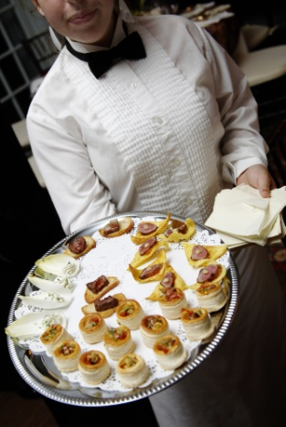
This section defines service flow and discusses relevant factors.

Service flow
‘Service flow’ refers to:
- The activities required to enable or support the process of plating and/or otherwise serving food
- Planning and sequencing those activities so they can be conducted in the most effective and efficient manner.

Relevant factors
When determining service flow the following factors must be taken into account:
- The service style required for the menu and individual service session:
- Every service style/option has unique food preparation and service requirements so there is a need to match the work flow to the type of service being provided – for example:
- Gueridon service will necessitate the preparation of trays of ingredients and service trolleys well in advance of the starting time for service
- Family and silver service requires not only preparation of the menu items which will be served but also preparation of the servicewear (platters, bowls, dishes, service gear, underliners) to enable those particular service options
- Traditional plated service requires decisions to be made about:
- Whether a ‘production line’ system should be used – where an empty plate has items added to it as it is passed (or moves by conveyor belt) along the line to final completion where it is checked and released for service
- Determination of where each food item that has to be served is to be located along the service line – to provide optimum service efficiency
- Whether an ‘individual’ plating approach to plating should be used – where meals are plated (all meat, vegetables, sauce and garnish) at the point they are produced/cooked and then taken ‘ready for service’ to the pass where they are given to wait staff
- A combination of the two above options should apply – this is the most common/frequently used option. Some meals are plated/served using a production line approach and some are individually plated at point of preparation
- Need to allocate sufficient space for plating and service activities – so the process is not cramped and the risk of interference with service practices is avoided
- Need to allocate sufficient physical resources and equipment – such as bain-maries, holding equipment, service utensils and service cloths to enable plating and service activities
- Need to allocate sufficient staff to undertake required plating and service activities – so that target/identified volumes can be achieved and quality plating procedures can be implemented as required
- Need to allocate specific plating and service duties to individual staff – so all workers are completely aware of their personal roles and responsibilities and there is no confusion about:
- What needs to be done
- Who is doing what
- Need to factor in any known/required service times – for example, the running sheet for a sit-down meal for a function of 1,000 people may require the a certain course to be served between 8:00PM – 8:20PM
- Your knowledge of your kitchen, general facilities, and standard service protocols may indicate to you a need to establish multiple service point/production lines/conveyor belts in order to meet this known service requirement.
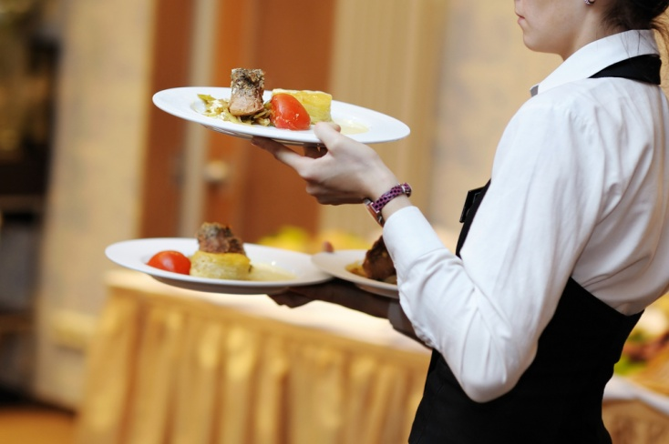
Work Projects
It is a requirement of this Unit you complete Work Projects as advised by your Trainer. You must submit documentation, suitable evidence or other relevant proof of completion of the project to your Trainer by the agreed date.
3.1 To fulfil the requirements of this Work Project you are required to:
- Provide a menu for a specific event/occasion food production and service session
- Describe the venue where the service is to take place and identify the number of customers expected to be served
- Explain and justify a service style appropriate to the specific event/occasion
- Identify the personnel, equipment and service flow required to serve/plate each dish on the menu in accordance with the selected service style.

Summary

Set up kitchen for food service
When setting up kitchen for food service:
Allocate staff to the serving/plating process
Train staff in food presentation requirements and standards
Allocate sufficient and appropriate service and portioning equipment and utensils to plating/service activities
Ensure consistent/uniform and attractive appearance of food on the plate
Select appropriate food service and display platforms
Factor in the need for standard portion sizes
Check the visual appearance of meals and plates before they are released for service
Understand the impacting of plating food on customer perception of the venue
Determine an appropriate service style to reflect menu, customer preferences and operational requirements
Establish a service flow to support and enable the requirements of the service style and menu.

Element 4:
Hold and store products for food service

4.1 Use appropriate preparation and cooking methods


Introduction
Most foods require some form of preparation and most menu items require some form of cooking.
This section introduces the concept of mise en place, presents various food preparation activities, defines and discusses a range of commonly used food cuts and shapes and identifies and describes a range of basic cooking methods.

Mise en place
This is a French term meaning ‘to put in place’.
Mise en place applies to both ingredients and equipment needed for a dish.
Examples of mise en place activities
Activities involved in mise en place can include:
- Making sure you have gathered all the ingredients and have weighed all quantities accurately
- Checking you have pots and pans clean and ready to use, and they are of the necessary size and number
- Checking fruit and vegetables to be used are suitable for use and have been washed and prepared as necessary
- Checking you have all the utensils you will need for the recipe – knives, spoons, whisks and other as required.
Mise en place is something to be done for every recipe, every time you cook an item.
Purpose and importance of mise en place
The purpose of mise en place is to get everything ready before you start cooking or food preparation so you do not have to interrupt the process while you look for something or get something ready.
If you have to interrupt the cooking/preparation process you run the risk of:
- Producing a poor quality end product because the required cooking/preparation procedure has not been followed
- Wasting food because the poor quality product has to be discarded
- Lowering customer satisfaction levels if they are served poor quality food
- Reducing the potential for repeat business if customers are not happy with the food they have been served
- Slowing down the service of food to customers and/or the production time of items.

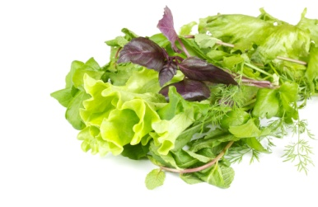
Washing, cleaning, trimming and peeling
Washing, cleaning, trimming and cutting fruit and vegetables is a common task in the kitchen and will often take up a large part of your daily routine.
Washing and cleaning
Most vegetables are grown either under the ground or just above the surface, so special attention to washing and cleaning is important to make sure all the dirt, sand, insects, insecticides and other chemicals are removed.
There may be a requirement to use sanitiser on fruits and vegetables.
The following procedures are generally applicable to the washing and cleaning of vegetables:
- Wash all vegetables thoroughly in cold water
- Green leafy vegetables (for example, spinach, lettuce, silver beet and kale) must be washed several times to make sure any insects and dirt clinging to the leaves are removed
- Root vegetables which are not peeled, such as potatoes used for baking, must be scrubbed well with a stiff brush under running cold water
- Vegetables like cauliflower and broccoli may be soaked in salty water for 30 minutes to kill any insects present
- Leeks need special washing to remove dirt which remains between the layers – after cutting leeks lengthwise, hold them under cold running water, separating the layers to remove the dirt
- Celery needs to be washed well – pay particular attention to the insides of the stalks which often need vigorous washing to remove clinging dirt
- After washing make sure all vegetables are drained well.
Peeling and trimming
After the vegetables have been washed and cleaned thoroughly, many need to be peeled and trimmed.
A peeler, a chef’s knife or a paring knife may be used to remove skin, root ends and blemishes.
Peelings
These are the outside skins, tops and tails from fruit and vegetables.
They usually have no culinary use and can be discarded.
Vegetables should be peeled or scraped thinly to remove only the skin, as most nutrients are just below the skin/surface.
Thin peeling also, naturally, minimises wastage.
The peels of some vegetables – such as zucchini and squash – are edible and therefore the vegetables do not need peeling: just wash them thoroughly.
Trimmings
Trimmings are the edible good quality off-cuts from fruit and vegetable preparation.
They should be saved for use in stocks, sauces, mirepoix and puree.
The flesh of some vegetables turns brown when exposed to air.
To prevent this happening the following procedures are recommended:
- Cover peeled potatoes in cold water until they are ready for use
- Jerusalem artichokes and eggplants can be placed in a mixture of cold water and acid, usually lemon juice or vinegar. For small quantities, the acid may be sprinkled directly onto the vegetables.

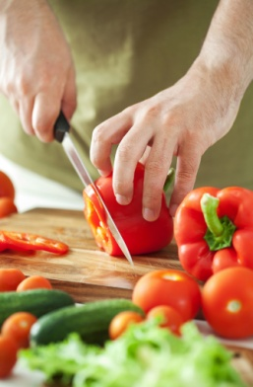
Cutting
A wide variety of fruit and vegetables is available for use in the kitchen and knowing how to prepare them correctly is essential.
Although one of the main goals in learning to cut is speed, you are advised to start slowly and pay attention to uniformity and accuracy in cutting. The speed can – and will – come after these two aspects are mastered.
Safety is always important.
Mincing and dicing
Mincing means cutting into very small pieces.
Dicing means cutting into slightly larger pieces (Macedoine and Brunoise, below, are a dice).
The end use for the item will dictate whether it is minced or diced.
Dicing an onion
Dicing an onion presents a special problem for cutting because it is layered rather than a solid piece. Practice dicing an onion as follows:
- Cut a peeled onion in halves from root to stem – do not remove the root
- Lay the cut surface on the cutting board and with the tip of the chef’s knife, cut each half lengthways at 2 mm intervals: do not cut through the root of the onion as this holds the slices together
- Next, make 2 – 4 horizontal cuts (depending on the size of the onion) at right angles to the other cuts. Now, you have cut the onion in two directions and the root end is still holding the pieces together
- Slice down through the onion at 2 mm intervals from top to bottom. The onion will fall onto the cutting board in small dice.
The piece left over containing the root is used in mirepoix or put into stocks.

Cuts and shapes
Food (especially vegetables) can be cut into shapes.
Accuracy in cutting is very important – the finished product must be very close to the measurements given below because uniformity of cuts:
- Provides a more eye-appealing product
- Means the food items will cook evenly.
Traditional vegetable cuts (note these cuts may also be applied to other foods too, but are more commonly called vegetable cuts) are as follows:
Note there is some variation about exact sizes for different cuts. Different venues may use different dimensions. Check how each vegetable cut is defined where you work to ensure everyone cuts to the same size.
The following table lists and describes the most common types of cuts used in basic preparation.
Method | Description | Examples of Use
Slice | Cutting a thin, broad, flat piece of food, usually by using a sawing action | Bread slices  Onion rings
Chop | To cut food into uneven bits by using short, sharp blows (food may be chopped fine, medium or coarse) | Chopped parsley for salads and duxelles
Shred | To cut into very fine, irregular strips | Lettuce, for use in salads  Cabbage, for use in coleslaw
Crush | To squash into fine, medium or coarse particles, often by using the side of the knife | Crushed garlic
Slices
The following procedure is recommended for slicing an onion:
- Remove the top
- Peel the onion by slitting the outer skin and peeling it off
- Cut the onion in half vertically from the stem to the root
- Remove the root – this permits the slices of onion to fall apart
- Finely slice the onion by cutting with even strokes in the same direction as the poles.(from root to stem)
The uses of sliced onion include making soups, sauces, stews, braises and vegetable dishes.

Coarse chopped
Coarse chopped cuts are ‘roughly’ cut vegetables.
That is, the size and shape do not need to be as precise or accurate as all other cuts because the vegetables are (usually) strained out of the product being produced and are not served to customers.
Cut size is commonly approximately 25 mm.
A ‘mirepoix’ is roughly chopped vegetables (carrot, celery and onion: thyme is added) used as basis for sauces and to improve flavour of cooked meats.
The size of the mirepoix (that is, the size of the pieces of vegetables) is determined by what it will be used for.
For example, the mirepoix for a fish stock would be smaller than the mirepoix for a beef stock because fish stock only takes 20 minutes to cook whereas beef stock takes 6 – 8 hours.
Chiffonade
This is a cut where the product (usually lettuce or cabbage) is cut into finely shredded strips.
See http://www.youtube.com/watch?v=aO-9VmnXHB8 (‘How to chiffonnade a lettuce’: 28 secs).
Julienne
These are strips of vegetables (such as carrots but can also be, for example, ham) that measure 2 mm x 2 mm x 40 mm long.
The procedure is:
- Top, tail and peel a carrot
- Cut the carrot into lengths of approximately 40 mm
- Square off the sides of each length
- Slice the carrot into thin strips 3 mm thick – take the thin strips, lay them flat on the cutting board, and using a chef’s knife, cut lengthwise to obtain smaller, thin matchstick strips.
Macedoine
These are vegetables cut into cubes.
They are bigger than Brunoise being 8 mm x 8 mm x 8 mm.
The procedure for preparing a macedoine of apple is:
- Peel and core the apple and place it into acidulated water (water with added lemon juice) until ready for use – placing the apple into acidulated water prevents it from oxidising in the air and turning brown
- Stand the apple upright and square it off, then cut the apple into 8 mm thick slices – place the slices onto the cutting board and cut into 8 mm strips, then cut the strips into 8 mm cubes.

Bâtonnet
This is a baton cut of 6 mm x 6 mm x 45 mm.
Potatoes and carrots are often cut this way.
Jardinière
These are small batons of vegetables, similar to Julienne but bigger being 4 mm x 4 mm x 20 mm.
Paysanne/fermière
These are thinly sliced triangular, round or square shapes.
The round shapes must be 15 mm in diameter, and the squares and triangles must have 5 to 10 mm thickness.
Lozenge
A thin diamond-shape cut about 6 mm thick.
See http://www.youtube.com/watch?v=ur85o7hgvyQ (‘How to cut a lozenge from a carrot’: 3 mins 20 secs).
Brunoise
These are small cubes measuring 2 mm x 2 mm x 2 mm.
The procedure is:
- Cut into julienne – the first step of cutting into brunoise is to cut into julienne
- Stack the julienne strips into piles and then cut through the pile of julienne strips at 3 mm spaces to produce the brunoise cubes – using this technique is much quicker than cutting one strip at a time.
Rondelle
These are round cuts (like a coin) of, for example, a carrot.
The rounds can be of different thicknesses for different uses – thinner cuts for salads, thicker cuts for use as a vegetable to accompany a meal.
Oblique/roll cut
A cut where the sides of the carrot are not parallel to each other.
This cut requires you to roll the carrot between cuts to obtain this unique shape and unusual shape.
See http://www.youtube.com/watch?v=jShrXQInpek (‘How to oblique cut on vegetable’).

Online videos
- http://www.youtube.com/watch?v=cV0c7qiNjuI (‘Basic knife skills 1 of 2’: 8 mins)
- http://www.youtube.com/watch?v=WSTBJ82nUts (‘Basic knife skills 2 of 2’: 7 mins 34 secs)
- http://www.youtube.com/watch?v=wvy_sUJKJ1U (‘Classic Carrot Cuts – Rondelle, Demilune, Paysanne’: I min 49 secs)
- http://www.youtube.com/watch?v=FpSEs_hEBG4 (‘Chef Kyle - Carrot/rondelle cut’: 2 mins 45 secs)
- http://www.youtube.com/watch?v=dtBssdM2nTU (‘How to Brunoise’: 28 secs)
- http://www.youtube.com/watch?v=ML5flgorZYc (‘How to Dice, Julienne, Brunoise and Batonnet’: 2 mins 57 secs).
Turned vegetables
Turning is the process where root vegetables (commonly potatoes and carrots are turned) of different sizes are shaped (or ‘turned’) into the same size and shape.
This results in even cooking and enhanced presentation/eye appeal.
The best knife to use for turning vegetables is a turning knife but a standard paring knife is also suitable.
The vegetable to be turned is first cut to the required size and then held in one hand: the knife is used in the other.
There is a knack to turning vegetables into regular-shaped barrels – one way to learn the even wrist action required for turning is to practice on a hardboiled egg (shell on): hold the egg lengthways between finger and thumb and scrape the blade lightly down the shell until you feel comfortable with the even flow of the knife.
An exception is turned mushrooms. A series of grooves are scored in a mushroom cap, at an angle of approximately 25°, removing the skin at the same time.
Turning a potato
The procedure for turning a potato is:
- Peel the potato with a peeler, wash and place it in cold water – peeled potatoes are kept in cold water to prevent them from oxidising in the air and turning brown
- Cut the ends off the potato squarely, then take the potato in one hand and with a slight curving action, slice the potato from top to bottom
- Rotate the potato slightly and repeat the action and continue to do so until you obtain a barrel-shape with six to eight even smooth sides.
Turning a carrot
- Peel the carrots and cut them into lengths
- Cut very large carrots into halves or quarters
- Turn each piece into even-sized barrels.

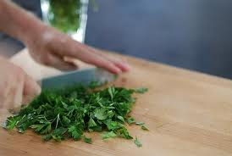
Chopping parsley
The following procedure is recommended:
- Separate parsley from stem
- Wash the parsley in a bowl of cold water
- Remove the stalks and finely chop the parsley with a chef’s knife
- Place in a clean cloth, fold over and wash under cold running water and squeeze out the surplus water so the parsley is dry and loose. This is important as you should be able to sprinkle chopped parsley. If the parsley is too moist it sticks together and can ruin the appearance of a finished dish.
Peeling a tomato
The only way to peel a tomato without damaging its flesh is by dropping it into boiling water first.
The following procedure is recommended:
- Wash the tomato and, with the tip of a paring knife, cut a small cross in the bottom
- Remove the eye of the tomato, that is, the stem end
- Drop the tomato into rapidly boiling water for 10 – 15 seconds
- Plunge it quickly into iced water
- The skin will now be split and easy to remove.
If some of the flesh comes away with the skin, it means you have left the tomato in the boiling water for too long.
The uses of diced onion include compound butters, sauces, duxelles and cooked tomato concasses.
Preparing citrus fruit
Lemons, oranges and grapefruits are frequently used for garnishing and can be cut into a variety of shapes.
The three common cuts are slices, wedges and segments.
Peeled slices
- Remove both ends of the fruit to just expose the flesh
- Stand the fruit on a cutting board and with a sharp knife and using a slightly curved action, slice off the skin and the pith without cutting too much into the flesh. After the first slice, follow the line of the exposed flesh
- Turn the fruit on its side and cut slices 3 mm thick and remove any pips.
Wedges
- Remove both ends of the fruit without cutting into the flesh
- Stand the fruit on a cutting board and cut in half. Then cut each half into four to six wedges, depending on the size of the fruit
- Remove any pips and cut off the strip of pith from the centre of each wedge.
Segments
- Cut off the ends of the fruit squarely so as to just expose the flesh
- Stand the fruit on a cutting board and with a sharp knife and using a slightly curved action, slice downwards following the shape of the fruit to remove all the peel and pith and as little of the flesh as possible
- Hold the fruit in one hand and, working over a basin, remove each segment by cutting along each side of it close to the membrane
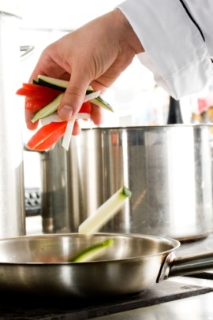
- Squeeze the juice from the core into the bowl.

Cooking methods
Cooking may be seen as the application of heat to food. There are many ways heat can be applied, and a wide range of equipment with which to apply it.
The recipe being used will dictate the cooking method to be used.
The cooking style is often indicated on the menu, too.
Boiling
Boiling is the principle of cookery in which food is completely immersed in liquid and cooked at boiling point (100°C).
Poaching
Poaching is the principle of cookery where food is completely submerged in liquid just below boiling point: there should be no visible movement of the liquid.
Braising
Braising is the principle of cookery where food is half covered with an appropriate liquid and cooked slowly in a tightly lidded container.
The food is usually left in large pieces which are carved before serving: the cooking liquid for meat is often used in a sauce however the liquid in which vegetables are braised is not used for sauce as it is too strongly flavoured.
Braising can be done in an oven or on the top of the stove.
Stewing
Stewing is the principle of cookery where the food is completely covered with liquid while it is cooking. The long cooking process gives a concentrated flavour and the sauce which are served together as a complete dish.
Steaming
Steaming is the principle of cookery where food is cooked by steam, either at atmospheric or high pressure.
A smaller amount of liquid is used than in boiling. The food to be steamed is suspended above the liquid which creates the steam. The steam should be contained within the cooking vessel. Steaming is a very nutritional method of cookery as no fats or oils are used and natural tastes are preserved.

Deep frying
Deep frying is the principle of cookery where food is cooked by total immersion in hot fat or oil. It is best suited to foods which can be cooked quickly.
Most foods need to be coated before deep frying to seal in the juices.
Baking
Baking is the principle of cookery in which food is subjected to the action of dry heat in an oven. This dry heat is modified by steam produced by the water content of the food being baked.
Roasting
Roasting, and spit roasting, is the principle of cookery in which food is cooked in an oven or while rotating on a spit.
Grilling
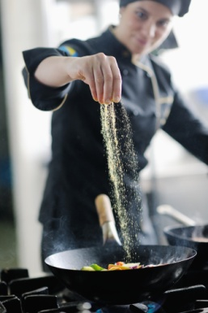
Grilling is the principle of cookery where food is cooked by radiated heat directed from above or below: in some cases the heat can come from both directions at once.
The source of heat can be charcoal, coke, gas or electricity.
Shallow frying
Shallow frying is the principle of cookery where food is cooked in a small amount of fat in a pan or wok.
This principle also includes pan frying, sautéing and stir frying.
En papillote
Cooking (by ‘steaming’) food in a wrapper of some sort.
The ‘wrapper’ may be a paper bag, aluminium foil, banana or grape leaves or bark.
See http://www.cookinglight.com/cooking-101/techniques/tasty-packages-en-papillote-steaming-00400000001016/.

4.2 Use appropriate equipment

Introduction
There is a need to use range of equipment when producing menu items.
This section presents a range of commonly used kitchen equipment highlighting the need to select the correct size and type of equipment for the job to be done.

Kitchen equipment
The selection of the right equipment for the job, and the knowledge of how to use it, allows your work in the kitchen to proceed smoothly, comfortably and efficiently.
Because there is such a large range of equipment available it is useful to group them into three categories: utensils, mechanical equipment and large (fixed) equipment.
Utensils
Utensils are small hand-operated pieces of equipment such as:
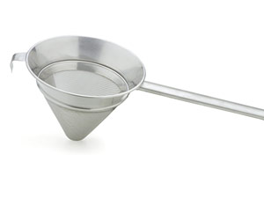
- Mouli – used to strain pips, skins and other material from purees and other mixtures
- Chinois – a conical sieve
- Whisk – used to whisk/aerate a variety of ingredients in many recipes
- Ricer – a piece of equipment (similar to an over-sized garlic press) used to make (for example) mashed potatoes.
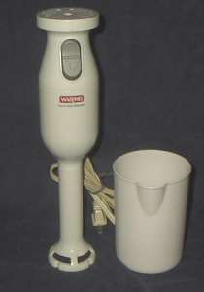
Mechanical equipment
Mechanical equipment can be large or small and is electrically operated and includes:
- Mixers – used for blending ingredients, liquidising foods and making sauces
- Slicers – necessary for slicing a variety of meats and other products
- Food processors – used for cutting and mixing food.
Large equipment
These are large pieces of equipment built-in to place in the kitchen. They can be electrically or gas operated and include items such as:
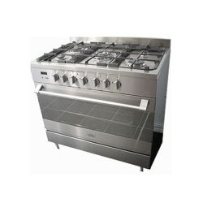
- Stoves – for baking, roasting plus use of burners on top of the stove for heating, re-heating and other stove-top cooking such as (for example) sautéing or boiling
- Salamanders – used to heat and brown foods as well as to prepare dishes like crème brûlée where the top of the dish has to be caramelised
- Steamers – required for steaming foods such as fish, seafood, chicken and vegetables
- Bain maries – usually used to keep hot foods hot while on display/waiting for service
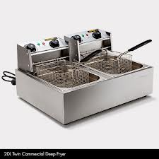
- Bowl cutter – used to chop/slice meat and to cut vegetables
- Mincer or grinder – used for mincing/grinding all types of meats and poultry
- Deep fryers – required for the cooking of a wide variety of dishes including battered fish and seafood, chips/French fries, fritters, onion rings, tempura vegetables
- Rotisserie – used for roasting (usually chickens)
- Bratt pans – a deep, rectangular, large capacity (50 – 120 litres) cooking pot used to prepare stocks, sauces, soups and wet dishes: has a tilting mechanism so foods can be tipped out into storage, display or service containers.

Correct size and type
When choosing the utensils and/or equipment for use in the kitchen, take the time and make the effort to get the right type and size.
Examples of this include:
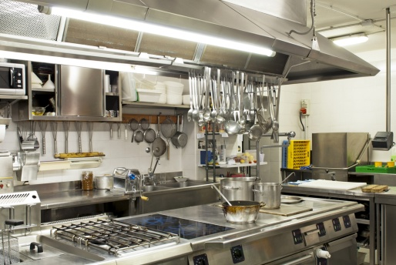
- Selecting a bowl to hold all the ingredients without them spilling over onto the floor or the preparation bench
- Getting a chopping board big enough for all the meat to sit on without it falling over onto the preparation bench
- Inserting oven trays in such a way to allow the entire batch to be cooked off in the one go
- Using small enough bowls, trays and dishes to enable quick refrigerating and freezing of foods to be stored.
Reasons to choose and use the correct equipment
It is important to choose and use the correct equipment because it can:
- Reduce preparation time
- Save energy costs
- Increase safety Increase output
- Generate labour savings
- Achieve better results/final products.

4.3 Follow food safety requirements

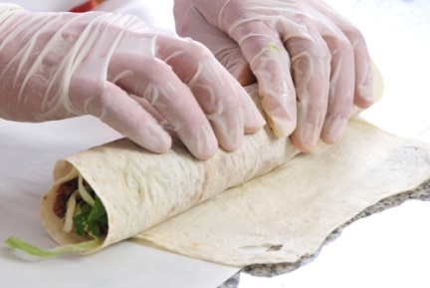
Introduction
All food produced must be prepared in accordance with safe food handling practices.
This section provides an overview of the food safety requirements which must be observed and implemented in as commercial kitchen. This section is not intended as a food safety course.

Important context
In relation to food safety and the application of safe food handling protocols you must:
- Observe the requirements of all national safe food handling legislation – as applicable to your host/home country
- Implement the requirements of any Food Safety Plan/Program which may apply to/have been developed for the venue where you work
- Apply all relevant enterprise policies and procedures relating to food safety – as determined by the individual employer
- Ensure you – and all kitchen staff/food handlers – have successfully completed relevant/accredited food safety training before handling food.

Scope of food safety
Potentially, food safety hazards exist in every food premises at every stage of food handling and there will be protocols which need to be adhered to each in each of the following stages:
- Purchasing food for use in the premises
- Receiving goods from suppliers into the premises
- Food storage prior to preparation and/or service
- De-frosting/thawing frozen food
- Preparing of raw materials for sale/service and the cooking food (including the cooling hot food for storage after it has been cooked)
- Cold holding and hot holding and display of prepared food for sale/service
- Re-heating of prepared food
- Serving food
- Self-service of food by customers to themselves.
In addition, workplace policies and procedures can be expected to exist to address other food safety-related issues such as:
- Cleaning and sanitising of food utensils, equipment, areas and food contact and preparation surfaces
- Specific food handling techniques required by the workplace to optimise food safety – as applicable to the equipment they use, the food they prepare and other factors applying in the premises
- Personal hygiene – and requirements applying to ensure staff do not contaminate food by their actions
- Equipment maintenance – and the need to keep food equipment, utensils (including food thermometers) and areas properly maintained to ensure they operate as required
- Use of food thermometers – to check food and equipment temperatures
- Pest control – to control vermin
- Waste disposal – to enable the proper removal of waste from kitchens
- Food recalls – to allow unsafe food to be recalled promptly and effectively and then be safely disposed of.

Potentially hazardous food
Potentially hazardous food is food that must be stored under special temperature conditions to prevent the growth of food poisoning bacteria, or to prevent the formation of toxins in the food.
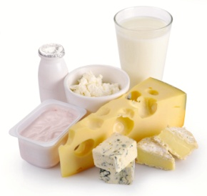
You must pay special attention to the following ‘potentially hazardous foods’ and make sure they are stored correctly at the right temperature (that is, out of the Temperature Danger Zone – see below):
- Milk and milk products, soft cheeses – butter, yoghurt, custards, cream cakes, cheese, baked custard tarts and dips
- Egg products – quiche, fresh pasta, duck and game bird eggs, all eggs, mayonnaise (whole egg)
- Meat and poultry – all cuts and types. Includes beef, ham, veal, pork, chicken, turkey – includes legs, mince, steaks, chops, cutlets, breast, wings
- Smallgoods products – ham, pressed chicken, but note most salami is not a high risk food due to its high salt and low moisture content
- Processed meat products including chicken – pâté, meat pies, sausages, sausage rolls, coagulated blood (in, for example, black pudding), rissoles, meat balls
- Fish, shellfish, fish products, fish soups and fish stocks – caviar, fish balls, patties, salads, sauces and stews
- Other prepared food dishes containing high risk food products – pizza, prepared meals, pre-made sandwiches and rolls, salads and cooked rice and cooked pasta.

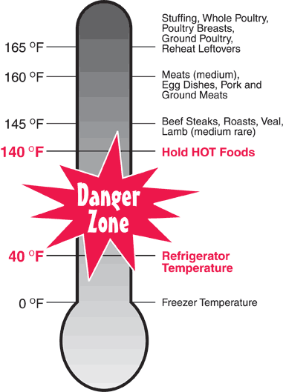
Temperature Danger Zone
It is important to know the Temperature Danger Zone because it is the temperature range in which bacteria multiply most rapidly.
The range is 5°C to 60°C.
Every effort must be made to keep potentially hazardous food out of this temperature range.
Where food must to be in this range (such as when it is being prepared), the amount of time the food spends in this zone must be minimised.
It is important to note all time food spends in the Temperature Danger Zone is cumulative.
For example, if a piece of meat is left out on the bench for one hour, refrigerated and then brought back out into the kitchen, the time it then spends in the Temperature Danger Zone is added to the previous time – the clock (and the bacteria count) does not get reset to zero when the food was put in the fridge again.

The 2/4 Rule
Awareness of the 2/4 rule is critical in applying safe food handling procedures.
The 2/4 rule states:
- Potentially hazardous foods that have been in the Temperature Danger Zone for 4 hours (or more) must be discarded/thrown out
- Potentially hazardous foods that have been in the Temperature Danger Zone for 2 hours can be refrigerated and then returned to the Temperature Danger Zone for another 2 hours, maximum
- When high risk food has been in the Temperature Danger Zone for 2 hours it must be cooked or eaten within the next 2 hours or thrown out.
There are no exceptions to this rule.

Calibrated food thermometer
All food premises should have at least one independent, calibrated food thermometer available to check the temperature of food (on delivery, during processing, while on display), and food equipment (such as fridges, coolrooms, freezers, bain-maries, food warmers).
It is best to use a probe thermometer which can be inserted into food.
This thermometer must be:
- Readily available for food handling staff to use as required – it should not be locked away in an office where you cannot obtain it easily
- Checked/calibrated very six months (minimum) to ensure it is giving an accurate reading
- Thermometers must be accurate to +/-1°C or they must be repaired or replaced
- Cleaned and sanitised between uses (to prevent cross contamination) when it is being used to check the temperature of food – the use of a sanitising wipe to clean and sanitise the probe is common
- Allowed to reach room temperature when being alternated between use on hot and cold food or vice versa
- Treated with care – do not knock, drop or damage it: if it is knocked, dropped or damaged, it should be immediately checked for accuracy.

Personal hygiene
In general terms all food handlers are under an obligation to observe and implement personal hygiene practices to minimise the possibility of food contamination.
Practices to achieve this include:
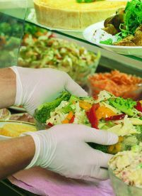
- Avoid touching food with the bare hands – use tongs, a spatula, fork, serving spoon or gloves when touching food especially food that will not be further cooked or processed
- Avoid touching food surfaces with the bare hands – this means avoiding touching preparation benches, preparation equipment and the food contact surfaces of serving items such as plates, bowls and cups with the bare hands
- No jewellery to be worn on hands and wrists – food can lodge in the jewellery, deteriorate and then fall back into food
- Facial hair must be kept neat and controlled – hair should either be covered or sprayed to keep it controlled in such a way that hairs do not fall into food. Long hair must be tied back, and beards should also be covered. In kitchens and food areas, hair nets or hats should be worn
- Fingernails must be short, clean and free of polish (including clear nail polish) –cracked fingernails and chipped nail polish can harbour bacteria and may also flake off into food. Fingernail decorations and artificial nails are also prohibited
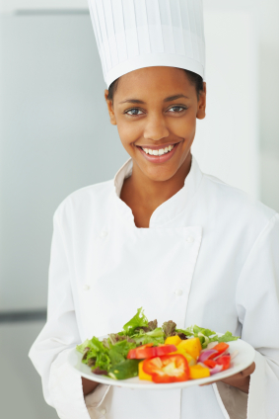
- Clothing must be clean – a minimum requirement is for clean clothes for each shift with further changes as spillages and 'working dirt' dictate. You are not permitted to wear ‘food handling’ clothes to and from work
- Cuts and sores must always be covered – a coloured, water-proof dressing must be applied and a finger stall also used where necessary
- Food handlers in the acute state of a common cold must not handle uncovered food – but they may work where food is in sealed containers
- Food handlers with any communicable disease must not deal with food until they receive a certificate from a doctor stating as a food handler they are cleared to work with food.

Disposable gloves
The use of protective, disposable gloves in food handling is an excellent safe food handling practice but gloves do not/cannot fix all food hygiene problems.
When wearing/using disposable gloves:
- Change gloves immediately they are ripped/torn – do not continue working while wearing torn gloves
- Change gloves between handling raw and cooked, ready-to-eat foods – to avoid cross contamination
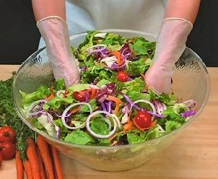
- Change gloves every hour regardless – you cannot wear the same pair of gloves for longer than this, or for an entire shift
- If handling money do not use the same gloved hand to handle food – take one glove off, handle the money with that hand (without the glove on), and then put on a new/clean glove before returning to food handling duties
- If changing gloves during service, ensure they are not taken off over food/food surfaces – if the gloves contain powder, this may fall out onto food or food preparation surfaces and provide a source of contamination
- Do not try to put on gloves that have already been used – disposable gloves must be disposed off/thrown out as soon as they are taken off
- Do not turn gloves inside out and try to wear them again – see above
- Change gloves whenever they become contaminated from whatever source – raw food, blood, sneezing, chemicals, scratching the face, handling rubbish.

Clothing, personal protective clothing, bandages and dressings
Dirty clothes and infected cuts and sores all pose a food risk.

You must:
- Ensure anything from your body or anything you wear does not contaminate food or food surfaces:
- Avoid loose-fitting clothes
- Do not cough or sneeze over food
- Avoid items of jewellery that hang down/dangle
- Avoid wearing rings when working with food
- Do not wear food handling clothes to and from work
- Remove protective clothing (aprons) when using the toilet

- Take appropriate measures to minimise contact with ready-to-eat food. Practical measures in this regard include:
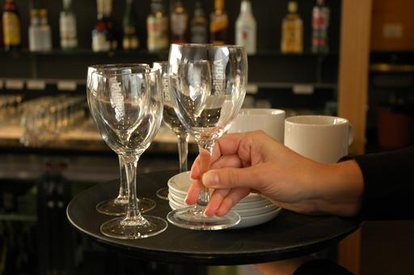
- Not handling cooked, and/or ready-to-eat food with the bare hands – use tongs
- Handling glasses and cups by their base – and not by the rim
- Handling cutlery by the handles
- Avoiding unnecessary skin contact with food contact surfaces
- Keeping hair tied back – wearing hats or beard nets helps ensure hair does not fall into food
- Avoiding touching hair while working with food – as this can transfer bacteria
- Keeping fingernails short – to avoid physical contamination from the nail (and to make them easier to clean)
- Wearing disposable gloves when handling food – and changing them regularly/as required
- Avoiding nail polish, fingernail decorations and artificial fingernails
- Wear clean clothing when handling food. Practical measures in this regard include:
- Wear clean clothes to work daily
- Have a change of clothes available at work – to change into if one set of clothes becomes dirty/contaminated
- Wear protective clothing such as aprons
- Use waterproof bandages and dressing on exposed parts of the body where there are cuts and/or sores when handling food. Practical measures in this regard include:
- Wear only coloured band-aids when handling food – they are easier to identify if they fall into food
- Wear a finger stall over a bandage/dressing on a finger – to give extra protection and security
- Wear a disposable glove over a bandaid, dressing or bandage that is on the hand.

Receiving food
The safe food handling requirements in relation to food receipt are:
- Inspect the deliveries – you should conduct a visual inspection of deliveries to make sure:
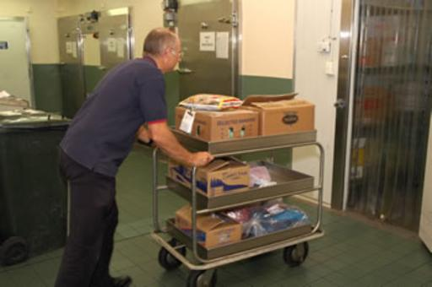
- The food is free from visible contamination – frozen food must be hard frozen; packaging and wrapping must not be torn; the integrity of tins and packets has not been compromised and they are not leaking; the food was not delivered amongst chemicals; the food does not smell ‘off’; cans are not ‘blown’
- The delivery does not bring in pests or rodents – spiders, cockroaches, mice
- The use-by dates of the food are acceptable – reject any food delivered beyond its use-by date
- Inspect the food delivery vehicle – check it is clean (see definition below) and is a dedicated food delivery vehicle. Food should not be delivered to food premises in private vehicles – dedicated food transport vehicles should be used
- Check the practices of the delivery driver – check things such as:
- Whether or not food is protected during the delivery process – is the delivery vehicle left unlocked during deliveries? Is food placed on the footpath? Are there chemicals mixed in amongst the food items?
- Personal hygiene of the delivery driver
- Check the temperature of the food is in accordance with the following using a properly calibrated thermometer:
- Frozen food should be hard frozen with no evidence of defrosting
- Hot food that is ‘potentially hazardous’ must be at 60°C or above
- Potentially hazardous refrigerated food must be at 5°C or below.
Note: potentially hazardous food may be accepted where the delivery driver can prove to your satisfaction the combination of time and temperature have not adversely impacted on food safety.
In general terms, if the food has been in the Temperature Danger Zone for 2 hours or longer the food should be rejected.
When accepting a delivery of potentially hazardous food in the Temperature Danger Zone, it should be used first/immediately and not be subject to the standard stock rotation principle of First In, First Out
- Check all packaged food is properly labelled with the name of the supplier, manufacturer or vendor – all food delivered into a food premises must be able to be identified to assist with food recalls and to help identify the source of problems/contamination where an outbreak of food poisoning occurs
- Store all deliveries as soon as possible after they have been delivered and checked – never leave refrigerated or frozen food lying around in the receival area as their temperature will quickly rise.

Handling food
‘Food handling’ is any activity that involves the handling of food (including preparing, cooking, thawing, serving, displaying food), so it is important these notes are read in conjunction with other food safety information provided.
General requirements include:
- Ensuring only safe and suitable food is processed – food unfit for consumption must not be processed. This includes foods that:
- Looks or smells ‘off’
- Shows other signs of contamination
- Exceeds its use-by date, or food taken from a source where the integrity of the packaging has been compromised
- Protecting food being prepared from contamination – this includes preventing contamination from:
- Physical sources – such as hairs, broken glass, dead flies, dirt, dust, airborne contamination
- Chemicals – such as fly spray or the introduction of cleaning chemicals into the food
- Microbiological contamination – which may be caused by leaving potentially hazardous food in the Temperature Danger Zone for too long while it is being processed, or failing to cook food at the correct temperature.
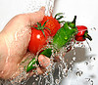
High risk food should reach an internal temperature of 75°C which should be verified with a thermometer
- Ensuring all fruit and vegetables are washed in a sanitising solution before being prepared
- Excluding unhealthy people from food handling/processing activities
- Using only clean equipment and utensils that have also been sanitised – and are in proper working order
- Ensuring chemicals are kept separated from food and food utensils and equipment during processing – all chemicals must be stored separately from food
- Keeping individual batches of processed food separate – batches of prepared food should never be mixed together (e.g. in a bain-marie) as this can give rise to situations where food may remain able to be served even though it has passed its safe food date/time
- Avoiding touching food with the bare hands where that food will not be subsequently cooked – it is best practice to wear disposable gloves or to use utensils to handle all food

- Using colour-coded chopping boards to reduce the likelihood of cross contamination:

- White – for dairy products only
- Red – for raw meat only
- Blue – for seafood only
- Yellow – for poultry only
- Brown – for cooked meat only
- Green – for fruit and vegetables only
- Discarding any food dropped on the floor – never use any food after it has been dropped on the floor
- Washing and sanitising any food handling tool, implement or utensil that has been dropped on the floor before re-using it
- Avoiding coughing or sneezing over food or food preparation utensils, equipment or surfaces
- Using a tasting spoon to taste dishes – never use any utensil to taste food and then replace it in the dish/pot, or use it for stirring.
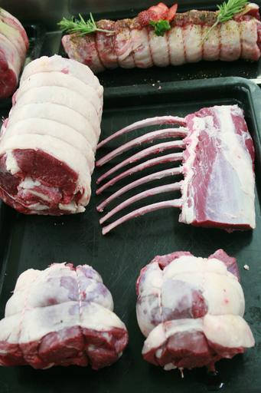
Thawing food
Frozen food must be thawed before use.
There are only three acceptable ways to thaw food:
- In a refrigerator/coolroom
- If pressed for time, use a microwave to defrost, moving pieces of food during the procedure
- Run the item under cold water (less than 20°C) – only suitable for small portions/items, and unsuitable where the item is breaded/crumbed.
All meats should be cooked immediately after thawing.
It is not acceptable to thaw items out by placing them in a bowl or sink of water.
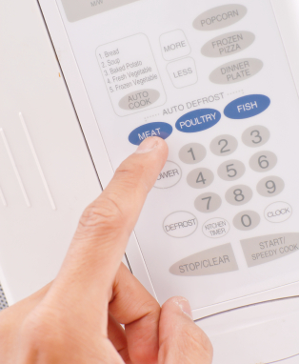

Storing food
There are three basic storage methods:
- Dry goods storage
- Refrigerated goods storage
- Frozen goods storage.
The standard safe food handling requirements in relation to food storage are:
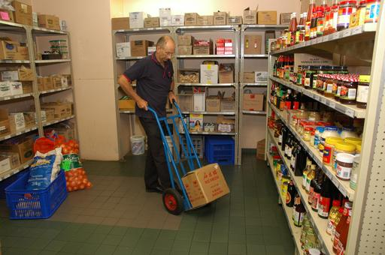
- Use food grade materials to store food susceptible to contamination – such as stainless steel
- Cover food in storage – to protect it from contamination
- Rotate stock to ensure it is used in the correct sequence – the method used for most food is called ‘First In, First Out’ (see below): any food exceeding its use-by date must be thrown out
- Keep all storage areas and equipment clean
- Never store food (including packaged food) directly on the floor – use shelves
- Ensure pests and rodents are excluded from food storage areas – conduct a regular inspection to check this, and take appropriate action when evidence of pests or rodents is discovered.
Dry goods store
The dry goods store is a non-refrigerated store where canned and dried food is kept. It may be room-size, a variety of cupboards and/or a pantry.
Ensure:
- The area is fly- and vermin-proof – to minimise contamination by pests
- It is well ventilated and lit – to deter pests and to allow staff to see what they are doing and identify and remedy spillages and vermin
- It is never overstocked – excess stock costs money, clutters things up, and increases the chance of out-of-date stock
- It is fitted with doors making a proper fit when fully closed – to help exclude pests
- The lowest shelf is sufficiently far enough above floor level to enable air circulation around goods, and allow mops and brooms to get under the shelves when cleaning is required
- Bulk food containers are made from food grade materials and have tight-fitting lids – plastic garbage bins are not permitted to be used for food storage as they are liable to splitting, do not have a smooth internal surface to facilitate cleaning and do not protect sufficiently against mice and rats
- Food storage containers are cleaned and sanitised before being re-used/re-filled – to guard against batch-mixing
- Any canned, tinned or bottled food must be transferred to an appropriate container and refrigerated once the container has been opened – it is not acceptable (for example) to open a can, use half the contents and then return the open can to dry storage. The food must be transferred to a plastic or stainless steel (or other appropriate) container and then placed in the refrigerator.

Refrigerated goods store
Refrigerated storage is used for fruit and vegetables, dairy products, meat and all other potentially hazardous foods.
Refrigerated storage may occur using coolrooms, under-counter refrigeration units or domestic refrigerators.
Ensure:
- The temperature is kept at 5°C or below and is checked with an independent calibrated thermometer – checks must be done at least once per day
- The maximum time high risk foods should be stored at 5°C or below is 7 days. Foods should be eaten within this time or discarded. Where the temperature is 3°C or less, this time could extend beyond 7 days
- The coolroom/refrigerator door is closed between uses and an effort made to minimise opening times by planning openings – an open door raises the temperature and makes the unit more expensive to operate
- The cool room is not overcrowded – to enable air to circulate freely around food items
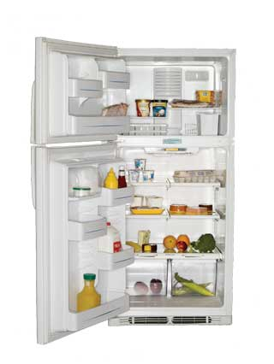
- Food loads put into the coolroom/refrigerator are broken down into smaller units to enable faster cooling – where large units of food are placed in the refrigerator it takes a lot longer for the core of the food to move out of the Temperature Danger Zone.
Hot foods should be allowed to cool (for example, by placing the food in pots and then into tubs full of a water-ice mixture) before being placed in the cool room. Frequent stirring of the food will help it to cool quicker.
The ‘Two-step rule’ for cooling hot foods must be complied with
- All food is covered and protected from contamination – plastic film with a label attached to identify the food and date it was placed under refrigeration should be used
- Potentially hazardous raw food is separated from cooked and/or ready-to-eat foods – this is to prevent cross contamination
- Never store potentially hazardous raw food above cooked and/or ready-to-eat foods as there is the potential for raw blood or juice to drip down onto the food below.

Frozen storage
Freezers are used to store frozen produce.
Freezers may be chest type, up-right, or walk-in, but they must be maintained so food remains hard frozen (recommended temperature is -15°C or below.
Ensure:
- Hot food is never frozen – cool it first following the two-step rule
- Thawed items must never be refrozen – once de-frosted, food should be used or thrown out
- Freezers are defrosted regularly – to maintain operating effectiveness and encourage turnover of items
- Freezer doors are kept closed when the freezer is not in use – to keep cold air in
- Freezer temperature is be checked at least daily – to ensure correct operating temperature
- Large pieces/amounts of food are not frozen as this encourages others to defrost the item and then re-freeze it – in practice this means freezing slices of meat rather than slabs of meat, and using shallow storage containers rather than deep ones to freeze food
- Manufacturer’s instructions regarding the storage of frozen food products are followed – these may relate to storage temperatures and the length of time the product can be stored (for quality and/or food safety reasons).
First In, First Out stock rotation
Effective stock rotation for foods means using the FIFO approach to stock rotation.
This method requires food to be used/served in the order it was delivered meaning the foods in stock the longest are used first. In practice this means when storing food:
- Old/existing stock must be moved forward on the shelf and the newly delivered stock must be placed behind it – this allows the stock at the front (the oldest stock) to be used before the newer stock
- Existing product in a chest freezer should be removed and the new stock placed at the bottom of the freezer – the existing/old stock is then replaced in the freezer on top of the newer stock
- Check use-by dates of products – and store them so the nearest date is at the front so it will be used first.
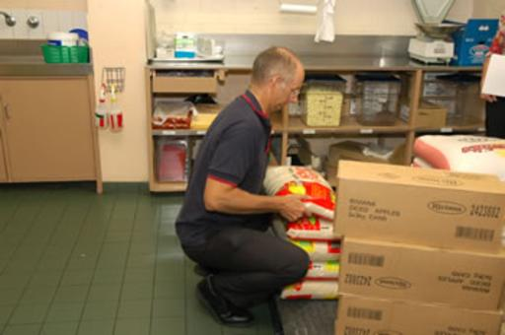

More food preparation and handling protocols
Two-step rule for cooling hot food
The two-step rule provides explicit direction for the cooling of high risk, hot food.
Step 1: Cool hot food down from 60°C to 21°C within 2 hours of removing the food from the stove, oven or other cooking unit.
Step 2: Once the food has reached 21°C it should be placed into a refrigerator/cool room, and then cooled to 5°C (or below) within a further 4 hours.
If the cooling of high risk food does not meet these criteria, the food must be thrown out to optimise food safety.
Once the food has reached 5°C, it can safely be put in the freezer.
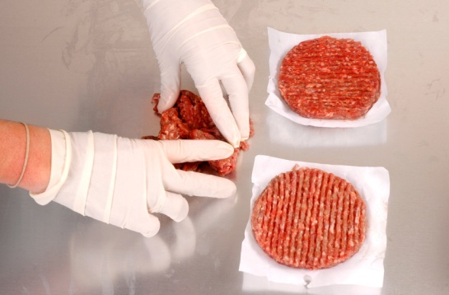
Cross contamination
Cross contamination is the contamination of food (or food preparation surfaces, equipment, utensils) with bacteria, chemicals or allergens as a result of contact with a contaminated source.
Bacteria cannot fly, jump or hop so they depend on people to move them around from place to place via direct contact or through indirect contact.
Examples of direct contact are:
- Using a knife to cut raw meat and then using the same knife to cut cooked, ready-to-eat meat without cleaning and sanitising the knife in between tasks – the blood and residual meat on the knife will carry bacteria and this will be transferred by the knife to the previously safe cooked, ready-to-eat meat
- Using a chopping board to cut raw chicken and then using the same chopping board to cut cooked meat for salads without cleaning and sanitising the board in between tasks – the chopping board will carry bacteria from the uncooked chicken (the cooking process should destroy the bacteria) which will then be transferred to the previously safe to eat cooked meat.
Examples of indirect contact are:
- Coughing or sneezing into your hand, and then using your hand to prepare/touch food or to touch a food preparation surface without first washing it to remove the contaminants.
The primary causes of cross contamination are:
- Linen items (uniforms, tea towels, towels, swabs, handkerchiefs, cloths) that are contaminated with human waste such as blood and secretions, and food residue (such as food that has been wiped up after a spillage or in order to clean a plate for presentation purposes)
- Dirty equipment – which is used to process, hold or serve food
- Dirty utensils – which is used to serve or eat food
- Raw food making contact with cooked/ready-to-eat food or surfaces that will be used to prepare or serve cooked/ready-to-eat food
- Failure of food handlers to wash their hands when and as required.

Ways to prevent cross contamination
The following techniques will help reduce the likelihood of cross contamination:
- Wearing clean clothes and clean protective clothing for each shift
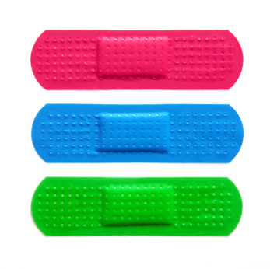
- Cleaning and sanitising food equipment, utensils and preparation areas in accordance with the cleaning schedule for the premises – including cleaning and sanitising of preparation benches in between preparing raw high risk food and other foods
- Using waterproof bandages and dressings on cuts and sores
- Washing – and properly drying – hands when and as required
- Storing cooked, ready-to-eat food above raw high risk foods
- Separating the storage of raw and cooked/ready-to-eat foods
- Keeping foods covered as much as possible when in storage, while being processed and displayed
- Using separate sinks for washing ready-to-eat salad vegetables/vegetables and other high risk foods – this includes a requirement a sink used for thawing high risk foods by running it under cold water should take place in a different sink to the one used for washing salad vegetables/vegetables
- Allocating different food handlers to raw foods and cooked/ready-to-eat foods
- Storing chemicals separately from food items
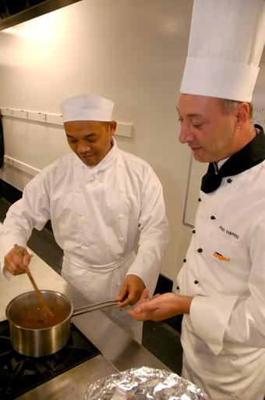
- Not wearing food handling clothes to and from work
- Using disposable towels instead of cloth towels
- Changing disposable gloves whenever there would be a need to wash hands – such as in between handling raw high risk food and cooked/ready-to-eat food: gloves should be changed every hour regardless
- Using colour-coded chopping boards
- Not mixing batches of food
- Refraining from tasting food and replacing the spoon back in the pot, tray
- Not coughing or sneezing over food or food preparation equipment, utensils or surfaces
- Cleaning and sanitising knives in between cutting raw high risk foods and cooked/ready-to-eat foods
- Cleaning and sanitising food preparation benches and equipment that are in constant use at least every four hours
- Avoiding the use of equipment and materials - including cleaning materials - between other areas of the premises and the kitchen
- Repairing cracked surfaces in the food preparation area
- Excluding pests and implementing an effective pest control program – which may necessitate the use of a qualified professional external pest control company

- Discarding all food known to be contaminated – or suspected of being contaminated
- Excluding food handlers who are ill from food handling and food-related activities
- Displaying food in such a way it is protected from contamination by customers, especially children – including the use of sneeze guards, monitoring patron actions where self-service food is available and taking appropriate action when the potential for cross contamination is identified
- Disposing of any food dropped on the floor
- Disposing of any food returned from a patron – this includes food and beverage items
- Disposing of any single-use item used once and/or which has become contaminated (or is suspected of being contaminated) for any reason
- Using only food grade equipment to store foodstuffs
- Putting up signs/posters in the workplace to remind food handlers about cross contamination
- Inspecting food deliveries into the premises to ensure they are not contaminated by any visible sources.

Serving food
The serving of food by staff to customers is an example of ‘food handling’ so all previously mentioned safe food practices must be employed when serving food.
The basic safe food handling procedures for staff when serving hot or cold food are:

- Potentially hazardous food must be kept out of the Temperature Danger Zone – the temperature of display units must be taken regularly to verify the temperature is correct
- Remember: keep hot food, hot – at 60˚C or above and keep cold food, cold (at 5˚C or below)
- Clean serving utensils must be used
- Never touch food with bare hands – always use disposable gloves, tongs or some other item (greaseproof paper, a fork, a spatula) to create a barrier between the hands and the food in order to prevent cross contamination
- Food must be served into/onto clean plates, bowls or other items
- Plates and similar must be stored at the service point in such a way to protect them from contamination – including contamination by flies, dust, customers
- Food must be kept protected from contamination – keep doors on display units closed; use lids where provided on storage units
- Staff must apply safe food handling and personal hygiene practices such as:
- Not coughing, sneezing onto food
- Washing hands as required – see below
- Using disposable gloves, as required, and changing when required
- Never using food dropped on the floor
- Never using food that has been contaminated in any way
- Use different utensils to serve different food items – to avoid cross contamination (and also to eliminate different foods [or colours] being mixed in with other foods, which is often not wanted by the customer).

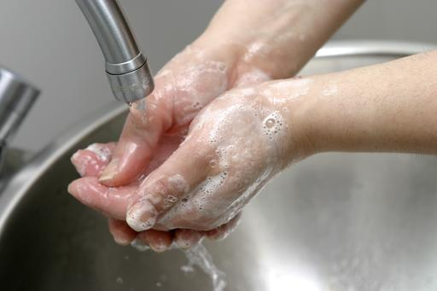
Hand washing
Health authorities believe the single most important aspect in preventing food poisoning outbreaks is for food handlers to wash their hands properly and to wash them ‘when required’.
When must food handlers wash their hands?
The times when food handlers must wash their hands are:
- Any time the hands are likely to be a source of contamination – this can include:
- After handling rubbish/garbage and before handling food or food contact surfaces
- After undertaking cleaning duties and before handling food or food contact surfaces
- After handling animals and before handling food or food contact surfaces
- After changing a baby’s nappy and before handling food or food contact surfaces
- After handling money and before handling food or food contact surfaces
- In between handling raw food (meat, fish or chicken) and handling other foods such as cooked and/or ready-to-eat food
- Before starting food handling duties – food handling staff must wash their hands when they arrive at work even though they may have showered, bathed or washed their hands at home before coming to work
- Immediately after engaging in nominated activities proven to be associated with bacterial transfer/cross contamination. The nominated activities include:

- Smoking – including using tobacco products
- Coughing or sneezing
- Using a handkerchief or nasal tissue – which includes blowing the nose
- Eating or drinking
- Touching hair, scalp, mouth, nose, ears, anybody opening or any wound
- After any absence from the work station – this means every time a food handler leaves the kitchen (or other place where they are handling food), they must wash their hands on their return to work and before they handle food. These absences from the work station may involve or be caused by:
- Leaving the kitchen to accept a delivery of food into the premises from a supplier
- Taking a phone call
- Doing another job that is not a food-related task
- Immediately after using the toilet and before handling food or food contact surfaces – this applies to all instances where the toilet was used and includes a requirement to wash hands after urination as well as after defecation.

4.4 Hold menu items

Introduction
Once food has been produced there can be a need to hold it ready for service.
This section addresses requirements for the display and holding of hot and cold foods.

Context
Equipment/cabinets can be used to hold and/or display:
- Hot food
- Cold food
- Frozen food.
‘Holding’ food refers to keeping food hot, cold or frozen after it has been produced while it is waiting to be served.
‘Displaying’ food refers to promoting food by putting it on show with the intent that ‘selling through seeing’ will occur.
It is necessary to train staff in practices required to safely hold menu items.

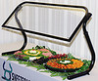
Holding/displaying cold food
Equipment used to hold or display cold food includes:
- Salad wells and cold plates
- Refrigerated cabinets
- Refrigerated bain-maries.
When using cold food display/holding units:
- Food should be held or displayed at or below 5°C – to keep it out of the Temperature Danger Zone
- Food should be covered/wrapped – to prevent contamination
- Temperatures must be regularly checked – at least daily using an independent thermometer
- Protective guards must be provided (where appropriate) – to prevent customers breathing, sneezing and coughing over the food
- Turn on the units and pre-chill them – before chilled food is placed into them
- Pre-prepared sandwiches and filled rolls should be stored under refrigeration – where they are not so stored, some system must apply (such as the use of colour-coded stick-on labels, or written times on the wrapping/container) that will allow control over the length of time the food spends in the Temperature Danger Zone.
- Pre-prepared sandwiches and/or filled rolls must not be sold/eaten when they have spent four hours or more in the Temperature Danger Zone
- FSPs usually require records to be kept of the temperature of cold food display/holding units – on a daily or sessional basis.

Holding/displaying frozen food
Where the business displays or holds frozen food there is a requirement the display unit holds food so it remains ‘hard frozen’ while on display.
A temperature of minus 15˚C or less is recommended.
FSP temperature records will need to be maintained.

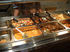
Holding/displaying hot food
Equipment used to hold or display hot food includes:
- Bain maries
- Pie warmers
- Hot food cabinets.
When using hot food display/holding units:
- The temperature of the food must be over 60°C (above/out of the Temperature Danger Zone ) – or the 2/4 Rule must be applied
- Food to be put in hot food cabinets must be preheated rapidly before being placed in the cabinet – never place refrigerated food directly into hot food units
- Turn on the units and pre-heat them – before pre-heated food is placed into them
- Food should be served in the order it was placed in the cabinet – to minimise risk of contamination, as well as guard against loss of taste, appearance and quality
- Hot foods left from the day before should be served before foods cooked today – appropriate stock rotation must apply
- Note some premises follow a standard operating procedure of discarding all left-over food
- Temperatures of food must be regularly checked (at least daily) – using an independent thermometer
- Food containers must not be topped-up – but emptied before being replaced with fresh food to avoid mixing batches.

4.5 Reheat menu items

Introduction
It is important to reheat menu items properly to maintain food quality and retain the safety of food.
This section identifies when the re-heating of menu items may be necessary and presents safe and accepted industry re-heating protocols.

The potential for re-heating menu items
There can be a need to re-heat menu items:
- When preparing leftovers – left-over food should only ever be re-heated once, and then discarded if not served/sold
- When preparing food which has been previously cooked and then intentionally refrigerated or frozen for later use.

Re-heating previously cooked food
The following steps should be followed when reheating previously cooked food, because many instances of food poisoning have been associated with incorrect reheating practices:
- Reheat in small quantities, not large – this reduces the time food spends in the Temperature Danger Zone (5°C – 60°C)
- Follow designated re-heating practices specified in the FSP for your workplace – this may include:
- Re-heating in a microwave oven
- Using a pot on top of a stove/range
- Re-heating in an oven
- Recording re-heating of food in accordance with FSP requirements – which may require you (for example) to record on a nominated basis (say, every two weeks the details of actual workplace re-heating, such as:
- Type and quantity of food which was re-heated
- Dates and times
- Method used for the process
- Start and finish temperatures
- Name of staff member who performed the process
- Do not use a bain-marie for reheating – as they are only hot holding devices and have not been designed as heating units
- Food must be protected from contamination while it is being re-heated – for example, by being covered during the re-heating process
- The bain-marie must hold the heated food at a minimum 60°C – so as to be above the Temperature Danger Zone (or The 2/4 Rule must be applied)
- It is preferable for food to be reheated immediately before service – rather than to reheat in bulk and held
- Stir wet dishes held in the bain-marie regularly to make sure the food does not cool down to below 60°C – this applies even where the units have overhead heating lights
- Previously cooked food, coming from the cool room or a refrigerator, that is going to be reheated, must be raised to 70°C (for 2 minutes) as soon as possible and then kept at a minimum of 60°C – never leave previously cooked food sitting around in the kitchen on a preparation bench in the Temperature Danger Zone
- A temperature monitoring probe should be used to check the internal temperatures of food that is re-heated – never rely on guesswork, or the visual appearance of the food.

4.6 Serve and present food items in line with customer volume

Introduction
All food produced by a kitchen should be served and presented to match expected customer volume.
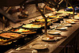
This section indicates how you can predict anticipated demand, identifies relevant issues related to the service and presentation of food, discusses the self-service of food by customers and service of unpackaged ready-to-eat food, and explains the use of and requirements applying to single-use items.

Determining demand
You can determine the expected demand for food for a service by using a combination of approaches:
- Checking the bookings/reservations which have been received
- Reading the ‘function sheet/file’ – where the session is for a function/event
- Reviewing past trading data
- Talking to experienced venue/kitchen staff.
Reasons to determine expected demand for food for a service session are to:
- Target production to the anticipated demand
- Save waste/over-production
- Reduce the potential for left-over food – which has to be saved for later use/re-heating
- Display/hold only the quantity of food expected to be required for the session.

Relevant issues
(Note: the following notes must be read in conjunction with ‘Serving food’ in section 4.3)
Issues warranting attention in relation to the service and presentation of food include:
- Protecting food at all times from contamination
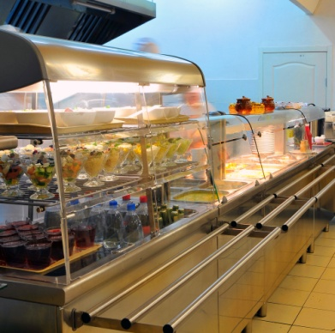
- Maintaining food at the correct temperatures
- Using designated utensils for serving food items
- Controlling portion sizes for each dish
- Verifying only clean and sanitised items are used for the service of food
- Adding necessary garnishes and/or sauces
- Adhering to identified location of food items on the pate when serving food
- Ensuring attractive appearance of the finished meal/dish
- Serving onto/into designated plates and/or single-use items
- Implementing all personal hygiene protocols
- Understanding the need for prompt/timely service of food.

Self-service of food by customers and service of unpackaged ready-to-eat food
Food may be offered to customers for self-service for consumption on the premises, or for consumption elsewhere/as take-away food.
This can include the provision of self-service salad bars and smorgasbords as well as the ability for customers to serve themselves with bread/rolls, or nuts and confectionery (in a retail outlet).
Providing this option for customers will present a higher level of risk from contamination because many elements of control have been given over to the customer.
It remains a legal responsibility on you to ensure the integrity of food offered in this style of service: if you cannot fully guarantee food safety by allowing the service of food in this manner it should not be offered in this way. Re-consider the service style and use another service/presentation method.
When offering self-service food and unpackaged ready-to-eat food, you must ensure:
- Customer activities are regularly monitored so unsafe practices can be identified and remedial action taken – this means a staff member must be appointed to watch customers in order to prevent them from doing anything to compromise the safety of the food, and to remove food when it has been contaminated
- Special attention is paid to children at self-serve areas – they are prone to handling food with their hands as well as taking food and then putting it back
- Hot food is kept hot (60°C and above), and cold food is kept cold (5°C and below)
- Any utensils dropped by customers are immediately replaced with clean and sanitised ones
- Spills are cleaned up immediately
- Any contaminated food is thrown out – this includes contamination caused by customers coughing or sneezing over the food
- Signs are posted advising customers of safe food handling practices – such as asking them:
- Not to use utensils in other foods
- To refrain from coughing and sneezing over the food
- To refrain from handling any of the food with their bare hands
- To supervise children
- Foods are covered and protected from contamination when not actually being used
- Separate utensils are provided for each food item
- Sneeze-guards are in place
- Batches and/or trays of food items are not mixed – stock rotation is important but so is the need to keep batches separate
- Throw out any plate waste/returned food
- Small batches of food are put on the smorgasbord – and replaced frequently, rather than putting out large trays or large amounts of food to begin with
- Extra utensils are provided – there always seems to be a need for more service spoons and forks
- Clean ‘rests’ for utensils (service spoons and forks) are provided and changed regularly to prevent cross-contamination
- The 2/4 rule is being complied with.


Single-use items
A single-use item is something intended to be used once in relation to food and then disposed of.
Single-use items must not be re-used even if they are cleaned in between uses.
Examples of single-use items include:
- Take away food and drink containers – including pizza boxes, coffee cups, boxes for hamburgers, packaging for rolls and sandwiches
- Drinking straws
- Disposable gloves
- Plastic cutlery
- Food wrappers – around items such as hamburgers and other take away menu items.

What requirements apply to single-use items?
Single-use items:
- Must not be used more than once by the business – customers are free to re-use them at home as they see fit: customers may also re-fill single-use cups themselves from drink dispensing machines.
Note: single-use containers may, however, be used by the business for non-food activities – such as collecting or storing dirty cutlery
- Must be stored and/or displayed so as to be protected from contamination – this contamination may be via:
- Flies, pests and vermin
- An infected food handler
- Airborne contamination
- Physical contamination
- Customers
- Must not be used if they have been contaminated – or there is suspicion they may have been contaminated: this can include:
- Disposing of any single-use items handled by customers
- Disposing of any single-use items dropped on the floor
- Disposing of any single-use items where the protective packaging they were delivered in has been compromised
- Must be clean in order for them to be safely used – meaning free from visible contamination of any sort (including food).
Practical measures
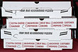
Practical measures to optimise safety when using single use items include:
- Not preparing pizza boxes in advance and leaving them ‘open’ – this allows airborne and other contamination to settle inside the boxes on the food contact area: pizza boxes should be constructed ‘to order’, when required
- Providing drinking straws in containers allowing only one straw at a time to be dispensed without others in the container being touched: an alternative is to only use individually wrapped drinking straws
- Storing take away food containers (for food and beverages) upside down – so the food contact surface of the container is not exposed
- Storing the lids to take away containers safely – so the side making contact with the drink/food is protected
- Disposable cutlery should be kept covered or individually wrapped
- Toothpicks should be individually wrapped.

Work Projects
It is a requirement of this Unit you complete Work Projects as advised by your Trainer. You must submit documentation, suitable evidence or other relevant proof of completion of the project to your Trainer by the agreed date.
4.1 To meet the requirements of this Work Project:
- Submit a menu for a specific event/occasion
- Select three items from this menu which require preparation and cooking
- For each of the three selected menu items:
- Identify/describe the preparation required for ingredients for each item
- Identify the cooking process(es) for each item
- Identify the equipment required to prepare and cook each item.
4.2. To meet the requirements of this Work Project:
- Prepare and submit four workplace posters which could be located in the kitchen to advise remind staff about:
- Poster 1: Food safety practices/requirements to be followed when preparing/cooking food
- Poster 2: Food safety practices/requirements to be followed when holding hot and cold food
- Poster 3: Food safety practices/requirements to be followed when re-heating previously cooked food for service
- Poster 4: Food safety practices/requirements to be followed when serving/plating food for eat-in and/or take-away service.

Summary

Hold and store products for food service
When holding and storing products for food service:
Undertake appropriate mise en place for all food production
Prepare items/ingredients uniformly and hygienically as required for their final use
Apply suitable cooking methods to dishes as designated by standard recipes
Select and use kitchen equipment appropriate to the required cooking styles and methods
Observe externally imposed obligations and internally required protocols (including ESP requirements) when handling food
Ensure all food handlers have successfully completed accredited safe food handling training
Follow all necessary safe food handling practices when ordering, receiving, processing, serving and displaying food
Implement personal hygiene practices
Wash hands as and when necessary – without exception
Complete required food safety records
Hold and display all food at correct temperatures protected from contamination
Reheat previously cooked food once only to required temperature
Determine how much food is required for each service session
Monitor all instances where customers can serve themselves
Never re-use single-use items.

Element 5:
Store products after food service to maintain quality

5.1 Store fresh and/or Cryovac items correctly

Introduction
After food service sessions have finished there is a need to store unused foods for later use.
This section discusses factors related to the correct storage of fresh foodstuffs and Cryovac products.
The notes in this section must be read in conjunction with ‘Storing food’ – ‘Dry goods store’ and ‘Refrigerated goods store’ in section 4.3.

Context
Correct storage of food items relates directly to quality and food safety.
Prepared foods must be stored in an appropriate vessel and at the correct temperature to ensure that it is not exposed to cross contamination or bacterial growth.
Other factors that can affect food quality include strong odours from other foods and elements that may affect appearance such as humidity, excess heat, air contact and natural enzymes in some fruits and vegetables.
Important point
Food that has been thawed/de-frosted must never be re-frozen.

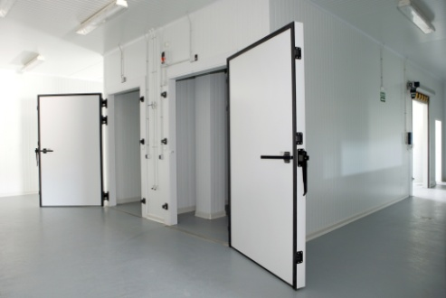
Coolroom temperature
The cool room is the most common storage area for foods, although some food items will suffer a loss in quality, especially in texture if stored under refrigeration.
Cool room temperature must be at or below 5°C in order to minimise bacterial growth, especially in protein foods such as meat, seafood, dairy and cooked starches such as rice.

Coolroom placement
All prepared foods including garnishes, condiments and accompaniments should be well covered or wrapped.
The most common and best medium for this is plastic cling wrap as it not only minimises cross contamination but does not allow circulating air to ‘dry out’ food items.
Plastic cling wrap can also create a barrier to strong odours from other foods that may be absorbed, especially in the case of dairy products.
Ideally, prepared food should be stored in a separate cool room from raw foods; however in many kitchens this is not practical.
As a standard rule, prepared food must always be stored above raw foods and away from strong smelling foods such as raw seafood or blue mould cheeses.

Time in storage
Safe Food Australia: A Guide to the Food Safety Standards (available at http://www.foodstandards.gov.au/publications/documents/complete_safefood.pdf) states:
“… safely maintained at refrigeration temperatures provided the time that the food is kept refrigerated is limited. The US Food Code (1999) specifies that the maximum time that potentially hazardous food should be kept at 5ºC is 7 days. If the food is kept for less than 7 days at 5ºC there will not be sufficient time for food-borne bacteria to multiply to dangerous levels. If a food business wishes to keep potentially hazardous food for longer than 7 days at cold temperatures, it will need to:
- Maintain the temperature of the food below 5ºc — for example, at 3ºc the food could be kept for longer than 7 days
- Keep the food frozen or
- Ensure that the food will not support the growth of the pathogens that grow to dangerous levels at refrigeration temperatures.” (p.41)
Ideally, prepared foods should be stored for no longer than 24 hours before using or discarding.
Excessive storage time will affect the quality of food items. Some examples of this include:
- Crumbed/breaded foods will absorb moisture and become ‘soggy’
- Dairy foods such as whipped cream may absorb food odours
- Sauces and custards can split or weep
- Leafy garnishes can lose moisture and wither
- Chopped fresh herbs can compost
- Fruits and fruit juices can ferment.

Time in freezer
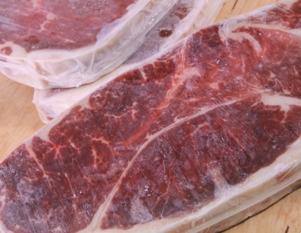
Ideal freezing temperatures are between -15°C to -18°C, depending on the type of food being stored.
Although freezing foods will stop the growth of bacteria, food quality can be affected by an excessive freezing period.
Prepared foods that are quickly frozen (within 2 hours) will lose less quality than foods that are slowly frozen.
Most prepared foods will freeze well for 2-3 months before beginning to suffer a loss in quality.
Defrosting should be done gradually and under refrigerated conditions. This is so the food does not lose too much moisture which would ruin the taste and presentation.
Again foods must be well wrapped. Plastic cling wrap is best as it contacts all surfaces of the food. Poorly wrapped food when exposed to circulating air at -18°C will suffer ‘freezer burn’. This is where the food will dry out leaving an unpleasant appearance and poor texture when cooked.

Storage on ice
The use of ice as a storage medium is commonly used for fish and shellfish.
These foods can deteriorate rapidly, even under normal refrigeration conditions (5°C). Storing in ice can bring the temperature down to between +1°C and +3°C. This temperature range will allow for longer storage.
In addition, the moisture created by surrounding ice will help to stop the food item from drying out.
If storing food on ice, it should be placed in a perforated container to allow water from melted ice to run off.

Storage in water
Leafy vegetables and herbs can lose moisture during refrigerated storage, leaving them withered and limp which makes them unpresentable.
Placing these items into very cold water for a brief period will allow them to absorb water back into the cells (osmosis) making them crisp and fresh looking.
Other food items that can be stored in water without losing flavour or quality include peeled and hard root vegetables.
Cut white fleshed fruits such as apples and pears will lose flavour and sweetness if placed in water so should be stored in stock syrup which is a boiled then cooled sugar/water mixture.

Cartouche
A cartouche is used in the storage of stocks, soups and sauces. Greaseproof or silicon paper or plastic cling wrap is used and placed in direct contact with the top of the liquid creating a barrier to air.
This stops a skin from forming which could create unattractive lumps if cooked back into the sauce or soup.

Vacuum packaging of meat
This is a system by which meat is placed in special plastic bags. All the air is then withdrawn using a special machine, which then heat seals the bag.
Meat packaged this way is normally stored at minus one degree to zero degrees Celsius (-1°C to 0°C).
This extends the storage life refrigerated meat:
- Beef up to twelve (12) weeks
- Lamb up to ten (10) weeks
- Pork up to three (3) weeks.
Sometimes after long storage then opening the smell can be quite strong. This will dissipate when left in the open air for a few minutes.
If the smell lingers, seek advice before using.
If in doubt, throw it out.
Storing of Cryovac meat products
Standard industry practice is:
- Store in pack until needed – at correct temperature and observing use-by date
- Remove from packaging and place on clean washable containers when product needs to be used – to stop excess liquid from spilling if packaging fails
- Meats that have a covering of fats (such as striploin) should be laid in container or on tray with the fat side up – to stop blood pooling and discolouration of fat
- Do not replace meat into original pack once it has been used/opened
- Labels should be facing out - so they can be easily read by staff.
Note
Time listed above for storage of meats only applies if temperature control is sufficient.
Refrigeration of 3°C will cut short this time.
It must be -1°C consistently.

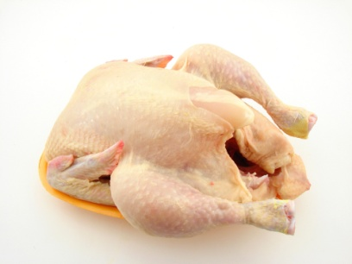
General storage of meat
Raw meat is a favourable medium for bacterial growth if not stored and handled correctly.
There are two main conditions to be met when storing meat.
They are:
- Temperature:1°C to 3°C
- Humidity: 85 %
General meat storage requirements
Other factors to be considered are:
- Place meat in single layers on trays – fat side up, including Cryovac packs
- Trays holding raw meat must be changed regularly to prevent blood pooling
- Meat must be covered with plastic wrap
- Different types of meat should not be mixed
- Raw and cooked meats must never be spread on the same tray
- A sound stock rotation program should be maintained
- Cooked meats should be stored on top shelves in coolrooms
- Prepped meat should be stored on second shelf of coolroom
- Packed or Cryovac meats should be stored on lower shelves
- Thawing meats should be placed on lowest shelves.

5.2 Change storage containers and trays to enterprise standards

Introduction
It is important to use storage containers and trays correctly in order to optimise food safety and minimise wastage.
This section lists considerations and points relating to the selection and use of storage containers, provides examples of storage containers and presents examples of possible relevant enterprise standards.

Considerations relating to storage containers
Containers, packaging and wrapping materials must be suitable and appropriate to the food item to be stored.
Considerations relating to the use/selection of storage containers/trays should address:
- Size of the container – will the food fit comfortably without being forced in?
- Shape of containers:
- Will the food lose its shape?
- Flat, shallow or deep – does the food require air circulation or rapid cooling?
- Condition – is the container cracked, broken or chipped?
- Hygiene – is the container clean and sanitised?
- Food grade – is the container of a ‘food grade’ standard?
- Later use – is the food to be cooked or heated in the container?
Advice/information on storage containers
- Stainless steel and hard plastics are most commonly used as food storage vessels – this is because they are sturdy, easy to keep clean and are non-porous
- Glass and ceramic bowls and containers may be used – however they are prone to chipping, cracks and breakage
- Cardboard boxes and cartons are not recommended for storage in coolrooms – as they can harbour insects and are prone to rotting and mould
- Cast aluminium vessels can react with some foods causing them to discolour, especially white sauces and egg based items so they should not be used – aluminium foil products do not have the same effect
- Decanted chemical containers should definitely not be used for food storage – as they may still contain traces of poisonous substances
- Storage containers must be clean and sanitised – before and after assembly and use.

Examples of food grade storage vessels
  Plastic disposable | 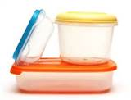  Tupperware | 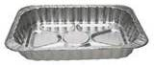  Aluminium foil
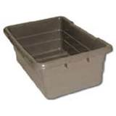  Plastic meat tub | 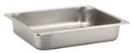  Gastronorm tray | 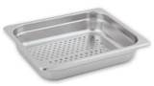  Gastronorm perforated tray
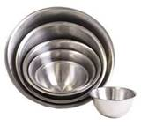  Stainless steel bowls | 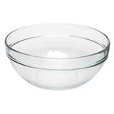  Glass bowl | 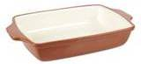  Ceramic dish

Packaging and wrapping materials
Other items used for storage include materials for covering food if an appropriate lid or storage vessel is unavailable.
- Plastic cling film/wrap
- Aluminium foil
- Silicon paper
- Greaseproof paper
- Plastic Cryovac bags
- Freezer bags
- Ziploc plastic bags.
All of these items are made from food grade materials.

Possible enterprise standards for storage
Venues/kitchens may have standards relating to the use of storage containers/trays such as:
- Bans on the use of glass or ceramic containers
- Frequency with which storage containers/trays must be cleaned/changed – such as daily
- Mandatory locations for the storage of certain items/products
- Guidelines (or mandatory requirements) on storage of leftovers – such as:
- No storage of left-over food – this is a common protocol in kitchens which service hospitals, aged care facilities and other venues where customers are in a high ‘at risk’ for food poisoning
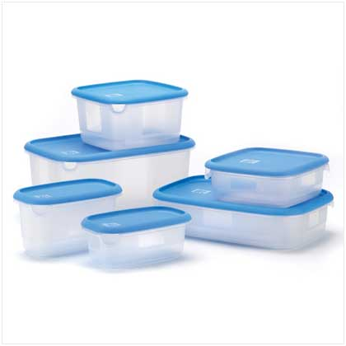
- Disposal of small quantities of left-over – as opposed to a requirement requiring all left-over food to be saved/stored
- Creation of menu items for the next service session which will use the left-over food from the previous session
- Specification of the type/style of storage containers and trays to be used for specified foods:
- For individual ingredients – that is, before assembly/production of menu items
- For prepared menu items – after dishes have been made (or are left-over)
- Alignment with any applicable factors impacting the kitchen, venue or country – as this may relate to dietary, cultural or religious matters
- The order/sequence in which individual items/foods are to be used – while FIFO is the usual practice for stock rotation of food there can be occasions where management/Head Chef wishes to apply an alternate option (such as, for example, Last In – First Out).

5.3 Label Items correctly

Introduction
Where foods have to be stored after a service session there is an industry-wide need to label them.
This section identifies why foods should be labelled when storing them and provides advice about the details to be provided on the labels.

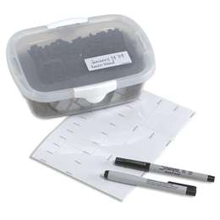
Reasons to label stored food
It is important to label stored foods in order to:
- Assist with stock control and rotation
- Help quickly identify stock-on-hand
- Facilitate retrieval of food items
- Maintain food safety of menu items
- Comply with FSP requirements
- Demonstrate safe food handling practices.

Labelling prepared menu items
All prepared foods should be clearly labelled prior to storage.
Information should include:
- Name of the item – a clear and accurate description of what the item is.
This is important because food is sometimes difficult to identify when it has cooled/been frozen.
For example, one sauce can look very much the same as other sauces; many wet dishes look similar
- Date the item was placed into storage – using an approved format readily understood by all staff.
For example, the format may be 02/03/2014, where:
- 02 = day of the month
- 03 = month of the year
- 2014 = the year
- Time the item was stored – this is necessary where the storage process is being recorded as part of process testing/verification under the FSP for the venue.
The 24-hour clock is usually used for this – for example:
- 0900 = 9 o’clock in the morning (9:00AM)
- 1515 = a quarter past three in the afternoon (3:15PM)
- 2030 = half past ten at night (10:30PM)
Where the storage is part of process testing/verification (record keeping) (such as checking the cooling of hot food, or the thawing of frozen food) there is also a need to record:
- The starting temperature of the food at the time it was placed into storage
- The finishing temperature of the food at the time the process(cooling or defrosting) was completed
- Type of storage – for chilling, thawing
- Name of relevant person – this may be:
- Person who produced the item, and/or
- Person who stored the product.
Writing must be legible and the label must be somehow fixed to the container.
Specialised labels
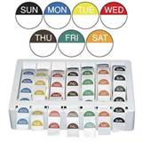
Many companies produce specialised labels for food storage, one of the most common is ‘day dots’, a colour coded labelling system which states the day of the week. The date is written in by kitchen staff.
Some labels are simple and only state the day and date, others have sections where other important information, such as in the above points, can be included.
The information provided on food storage labels will assist staff in making a decision as to whether the food is fresh, of a quality standard or if it is safe to use.

5.4 Store products in correct conditions to maintain freshness and quality and minimise wastage

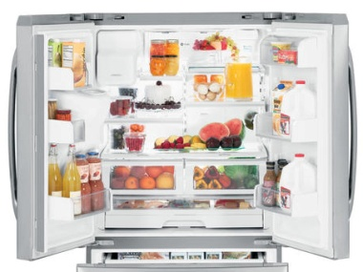
Introduction
Correct conditions should be used for the storage of food in order to maintain freshness and quality and minimise wastage.
This section identifies correct storage conditions, discusses stock rotation protocols, and presents examples of common storage practices for a range of garnishes and accompaniments.

Correct conditions
Conditions for storage of prepared food items will depend upon the type of food and how long it will be stored.
It is standard requirement all products should be stored under the correct conditions as soon as possible after food service has finished: food should (even foods not classified as potentially hazardous) should be stored at the earliest opportunity.
Temperature and humidity
Humidity levels can affect food items in storage.
Excess moisture in the air can be absorbed by crisp items such as biscuits, meringues, crackers and potato crisps.
This can lead to the item becoming soggy and even collapsing which can lead to poor presentation, especially is the item is a garnish designed to give height to a dish.
Dry, crisp food items should be stored in a cool dry area with little humidity.
Exposure to air
Some food items will lose moisture due to air exposure and low humidity. This is commonly referred to as ‘staling’.
Foods affected by staling through exposure include baked goods such as breads, cakes, pastries and biscuits.
By storing in an airtight container, staling will be drastically slowed.
White flesh fruits such as apples and pears, when peeled or cut begin to turn brown. This is due to enzymes in the fruit reacting with oxygen.
Coating or rubbing with an acid such as lemon juice will slow this process down, however the taste of the fruit will be compromised.
Storing in fresh water is not an option as the fruit will lose its flavour and sweetness through osmosis. These fruits should be stored in a sugar/water solution known as ‘stock syrup’ to minimise the osmosis process.
Protein foods such as meat, chicken and fish can dry out if not effectively covered or wrapped. This can lead to an unattractive appearance when the food is cooked and presented.
Refrigerated storage
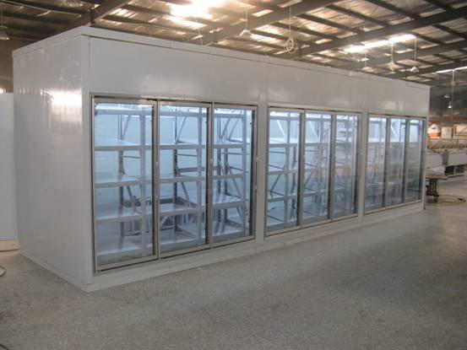
This requires foods to be subject to low humidity and a temperature of between 1°C to 5°C, depending on the food type.
Refrigerated foods will continue to deteriorate in quality and freshness over a period of time.
All prepared foods requiring refrigeration must be tightly wrapped or covered, labelled and dated.
Stock rotation principles must also be observed.
Frozen storage
This requires foods to be subject to low humidity and temperatures between -15°C to -18°C in a solid state.
Ideally, dairy foods such as ice cream should be as cold as possible (-18°C) as it will remain firm during periods when it is exposed to kitchen temperatures during service.
When storing foods under frozen conditions it should be packaged in small batches to allow rapid freezing to take place. Slow freezing allows large ice crystals to build up which breaks down cells in food, leading to excessive loss of moisture during thawing.
This leads to thawed foods having a dry appearance and texture when cooked.
Dry storage
This requires foods to be stored in a relatively cool area with very low humidity at between 18°C to 24°C. This is sometimes referred to as ‘ambient’ or ‘room’ temperature.
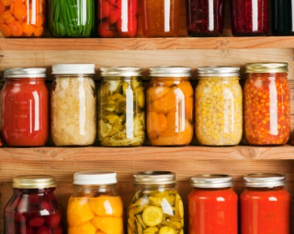
Most food should be wrapped, however this can have an adverse effect on some foods leading to sogginess if the area is too humid.
Foods should be stored in clean food grade containers that are pest proof.
Long term dry storage of any food will lead to staling, regardless of how it is stored.

Stock rotation
This sub-section repeats information presented in section 4.3.
First In, First Out stock rotation
Effective stock rotation for foods means using the FIFO approach to stock rotation.
This method requires food to be used/served in the order it was delivered meaning the foods in stock the longest are used first. In practice this means when storing food:
- Old/existing stock must be moved forward on the shelf and the newly delivered stock must be placed behind it – this allows the stock at the front (the oldest stock) to be used before the newer stock
- Existing product in a chest freezer should be removed and the new stock placed at the bottom of the freezer – the existing/old stock is then replaced in the freezer on top of the newer stock
- Check use-by dates of products – and store them so the nearest date is at the front so it will be used first.

Recommended storage of garnish items
Garnish | Storage requirements
Picked herbs  Salad leaves  Edible flowers  Shoots | In water and refrigerated – short term only.  Iced water will help to crisp up herbs and leaf vegetables quickly.
Chopped herbs | Rinsed and dried. Airtight container and refrigerated – short term only
Cut vegetables | Root and stalk vegetables - In water and refrigerated  Fruit type vegetables - Airtight container and refrigerated
Cooked vegetables | Airtight container and refrigerated– short term only
Cut fruits | Airtight container and refrigerated
Cut white flesh fruits | Coat with lemon juice to stop enzyme activity – ‘browning’ or store in a sweet stock syrup
Biscuits, pastry and croutons | Airtight container in dry storage area with low humidity
Seeds and nuts | Airtight container in dry storage area
Eggs, crepes | Airtight container and refrigerated – short term only
Sugar based garnishes  Meringues, candy and toffee | Airtight container in dry storage area– short term only

Recommended storage of accompaniments
Accompaniment | Storage requirements
Salsa, sambals, pastes | Refrigerate, covered or in bottles or jars
Prepared sauces and condiments | Refrigerate, covered or in bottles or jars
Prepared sauces and condiments – egg or dairy based | Refrigerate, covered or in bottles or jars
Dried chillies, nuts, fried shallots and herbs | Well wrapped or covered in cool dry area
Dairy foods – cream, cheese, yoghurt | Refrigerate, well covered and away from strong smelling foods
Breads, rotis, naan | Well wrapped or covered in cool dry area
As many accompaniments are quite strong in odour, it is recommended that you store these items away from dairy foods as these can easily absorb strong smells.
Work Projects
It is a requirement of this Unit you complete Work Projects as advised by your Trainer. You must submit documentation, suitable evidence or other relevant proof of completion of the project to your Trainer by the agreed date.
5.1 To meet the requirements of this Work Project you are required to:
- Identify three menu items (one fresh and two cooked/prepared) which are left-over from a food service/production session
- Describe how to store these items for later use/re-heating detailing:
- The storage container they will be stored in/on
- The correct conditions for optimum storage
- Produce a label suitable for attaching to each of the menu items when they are paced into storage.

Summary

Store products after food service to maintain quality
When storing products after food service to maintain quality:
Store foods after service as soon as they are no longer needed
Store fresh and prepared/left-over foods
Ensure refrigerated storage operates at or below 5°C
Verify freezers run at -15°C to -18°C
Use the storage option best suited to individual food type
Monitor the time food spends in storage
Left-over foods can only be re-heated once and must then be discarded if not used/sold
Change food storage containers and trays regularly to guard against cross contamination
Follow all enterprise and legislated requirements for the storage of food and use of left-overs
Label prepared and left-over food placed into storage
Create, maintain and monitor correct storage conditions
Implement suitable stock rotation processes focussing on the use of FIFO procedures.

Presentation of written work

1. Introduction
It is important for students to present carefully prepared written work. Written presentation in industry must be professional in appearance and accurate in content. If students develop good writing skills whilst studying, they are able to easily transfer those skills to the workplace.

2. Style

Students should write in a style that is simple and concise. Short sentences and paragraphs are easier to read and understand. It helps to write a plan and at least one draft of the written work so that the final product will be well organised. The points presented will then follow a logical sequence and be relevant. Students should frequently refer to the question asked, to keep ‘on track’. Teachers recognise and are critical of work that does not answer the question, or is ‘padded’ with irrelevant material. In summary, remember to:
- Plan ahead
- Be clear and concise
- Answer the question
- Proofread the final draft.

3. Presenting Written Work
Types of written work
Students may be asked to write:
- Short and long reports
- Essays
- Records of interviews
- Questionnaires
- Business letters
- Resumes.
Format
All written work should be presented on A4 paper, single-sided with a left-hand margin. If work is word-processed, one-and-a-half or double spacing should be used. Handwritten work must be legible and should also be well spaced to allow for ease of reading. New paragraphs should not be indented but should be separated by a space. Pages must be numbered. If headings are also to be numbered, students should use a logical and sequential system of numbering.
Cover Sheet
All written work should be submitted with a cover sheet stapled to the front that contains:
- The student’s name and student number
- The name of the class/unit
- The due date of the work
- The title of the work
- The teacher’s name
- A signed declaration that the work does not involve plagiarism.
Keeping a Copy
Students must keep a copy of the written work in case it is lost. This rarely happens but it can be disastrous if a copy has not been kept.
Inclusive language
This means language that includes every section of the population. For instance, if a student were to write ‘A nurse is responsible for the patients in her care at all times’ it would be implying that all nurses are female and would be excluding male nurses.
Examples of appropriate language are shown on the right:
Mankind | Humankind
Barman/maid | Bar attendant
Host/hostess | Host
Waiter/waitress | Waiter or waiting staff

Recommended reading
Arduser.L, Brown. D; 2005; The Professional Caterer's Handbook: How to Open and Operate a Financially Successful Catering Business; Atlantic Publishing Group Inc.
Bittman.M; 2012; How to Cook Everything The Basics: All You Need to Make Great Food; Houghton Mifflin Harcourt
Brown. Douglas; 2005; The Food Service Manager's Guide to Creative Cost Cutting and Cost Control; Atlantic Publishing Group
Cersani, Kinton & Foskett; 1995 (8th edition); Practical Cookery; Hodder and Stoughton
Coup, Bernadette; 2003; Mise en place: recipes and resources; Bernadette Coup
Cracknell.H,

Kaufmann.R; 2009 (3rd edition); Practical Professional Cookery; Cengage Learning
Dark .Graham, McLean. Deirdre & Weatherhead. Sarah; 2011 (2nd edition); Kitchen Operations 2nd Ed; Pearson Australia
Dodgshun. Graham,Peters.M; 2012 (6th edition); Cookery for the Hospitality Industry; Cambridge University Press
Feinstein. Andrew H, Stefanelli. John M; 2009 (2nd edition); Purchasing for Chefs: A Concise Guide; Wiley
H.L. Cracknell & R.J. Kaufman, Revised Third Edition, 1999; Practical Professional Cookery; Published by The Macmillan Press Ltd, UK
McLean.D,Satori.l, Walsh C&S; 2004; The Professional Cook’s book: Commercial Cookery; Tertiary Press
McWilliams, Margaret 2013; Food fundamentals; 10th ed, Pearson, Boston
McWilliams, Margaret 2013; Illustrated guide to food preparation; 11th ed, Pearson, Upper Saddle River, N.J
Knechtges, Paul L; 2012; Food safety: theory and practice; Jones & Bartlett Learning
McSwane.D, Linton.R, Rue.N; 2004 (4th edition); Essentials of Food Safety and Sanitation; Prentice Hall
National Restaurant Association; (2006, 6th edition); ServSafe Manager; Prentice Hall
The Culinary Institute of America (CIA); 2014 (4th edition); Techniques of Healthy Cooking; Wiley

Trainee evaluation sheet

Organise food service operations
The following statements are about the competency you have just completed.
Please tick the appropriate box | Agree | Don’t Know | Do Not Agree | Does Not Apply
There was too much in this competency to cover without rushing.
Most of the competency seemed relevant to me.
The competency was at the right level for me.
I got enough help from my trainer.
The amount of activities was sufficient.
The competency allowed me to use my own initiative.
My training was well-organised.
My trainer had time to answer my questions.
I understood how I was going to be assessed.
I was given enough time to practice.
My trainer feedback was useful.
Enough equipment was available and it worked well.
The activities were too hard for me.

The best things about this unit were:

The worst things about this unit were:

The things you should change in this unit are:

Trainee Self-Assessment Checklist
As an indicator to your Trainer/Assessor of your readiness for assessment in this unit please complete the following and hand to your Trainer/Assessor.

Organise food service operations
 |  | Yes | No*
Element 1: Plan for food service production
1.1 | Plan menu for specific event/occasion including resources
1.2 | Determine quantities required for food items as per standard recipes
1.3 | Order products required from suppliers with specifications for products
1.4 | Prepare production sheets/work schedules
Element 2: Prepare and produce food items for food service
2.1 | Identify and plan work flow
2.2 | Communicate with production team
Element 3: Set up kitchen for food service
3.1 | Place personnel ready for service
3.2 | Allocate equipment
3.3 | Determine service style to suit operation
3.4 | Determine service flow for service style
Element 4: Hold and store products for food service
4.1 | Use appropriate preparation and cooking methods
4.2 | Use appropriate equipment
4.3 | Follow food safety requirements
4.4 | Hold menu items
4.5 | Reheat menu items
4.6 | Serve and present food items in line with customer volume
Element 5: Store products after food service to maintain quality
5.1 | Store fresh and/or Cryovac items correctly
5.2 | Change storage containers and trays to enterprise standards
5.3 | Label Items correctly
5.4 | Store products in correct conditions to maintain freshness and quality and minimise wastage

Statement by Trainee:
I believe I am ready to be assessed on the following as indicated above:
Signed: | _____________________________ | Date: | ______ / ______ / ______
Note:
For all boxes where a No* is ticked, please provide details of the extra steps or work you need to do to become ready for assessment.





